**An End-to-End Azure Data Engineering Real Time Project Demo**

**Project Architecture:**

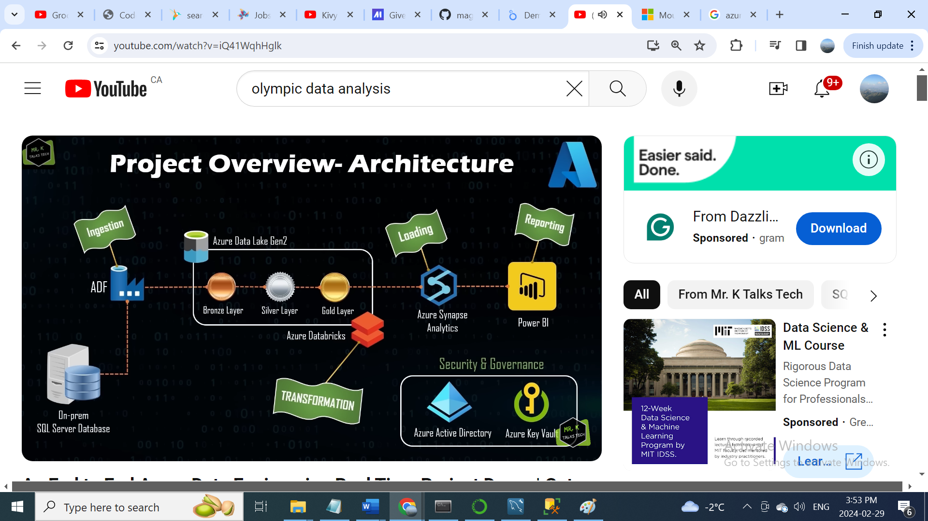

**Tools:**

* Azure Data Factory
* Azure Data Synapse Analytics
* Azure Databricks
* Azure Data Lake
* Azure Active Directory
* Azure Key Vaults
* Power BI

Data Source, we will use in this project On-premise SQL Server database. We are going to migrate this database completely to Cloud, so as part of this, first step would be using a tool called Azure Data Factory. So Azure Data Factory is a ETL tool, which is mainly used for data ingestion. So, what we are going to do is the Azure data factory will be used to connect to on-premise SQL Server database to copy all the tables from the database and move all the tables to the cloud and now where the tables will be stored in the Cloud so for that we are going to use Azure Data Lake Gen2. Azure Data Lake Gen2 is the storage solution in Azure and the data which is stored in Azure analyte is pretty cheap. So, we will be using Azure Data Factory to connect the on-premise SQL database and put all the data into the Azure Data Lake Gen2.

Once the data has been added into the Azure data lake, we will be using a tool called Azure Databricks to transform all the raw data into the most curate data. Azure Databricks is a big data analytics tool which is mainly useful for high-end data analytics workloads, so in simpler words we can say that using Azure databricks we can actually write the code either it is SQL or Pyspark or Python all the action development work will be done inside databricks. So, which is mainly used for actually transforming the data.

In this project is using Azure Databricks and Azure Data Lake, there is a concept called Lake House Architecture. What is the mean by Lake House Architecture is, for example Azure Data Lake will be divided into multiple layers, so what I mean by layers is we have different layers such as Bronze Layer, Silver Layer and Gold Layer, what are the difference between these layers?

So, as discussed before Azure Data Factory connects to the on-premise SQL database, copies the data and put the data into the Azure Data Lake. So, inside Azure Data Lake the Azure Data Factory puts the data first into the bronze layer, which means that the bronze layer has an exact copy of what the data looks like in the data source.

In this project we are not going to touch any data inside the bronze layer and we are not going to change the format or anything inside the bronze layer. So, this is going to be the source of truth, one

of the main advantages of this is for example in the subsequent data transformations that we are going to do, if something goes wrong you can come to this bronze layer and get all the data, which is going to be the same as the data source. Once the data has been copied to this bronze layer by Azure data factory, we then use Azure databricks to connect this bronze layer, do some data transformation and load the transform data into the silver layer, so this silver layer and gold layer is kind of have different levels of transformation, for example the first level of transformation is silver layer and the next layer of transformation is gold layer, so in bronze to silver layer the transformation might be kind of simple like changing the column names or changing the data types, because lot of times the on-premise kind of data types and the cloud data types is not really compatible, so we may need to change few things based on how it is going to support it into the cloud, so those kind of minimal transformation can be done in the silver layer and once the data has been transformed using Azure Databricks and the final data has been loaded into the silver layer. We then do another set of transformation using same usual Databricks and this data is going to be loaded finally to this gold layer, so this gold layer is the final cleanest form of data, so we all need to have a clean data right, so one of the main tasks of Data Engineers is to clean the raw data into the most curate data. Which means that all these data transformation is done by the Data Engineers using Azure Databricks in different zones, so that’s called Lake House Architecture.

Once the data has been loaded to the gold layer. Now, we are using another tool Azure Synapse Analytics, so you can think like Azure synapse Analytics is kind of similar to what is on-premise SQL Server Database. So, we can also create the same kind of database similar to how we can create using the on-premise SQL database. We can also create all these database and tables using Azure Synapse Analytics and once these database and tables have been set up in Azure Synapse Analytics, all the data that is present in the gold layer will be loaded to all the tables that we have created in Azure Synapse Analytics, so now at the end of this step the Azure Synapse Analytics will have a kind of similar data using model of how it looks like in on-premise SQL database, so you can consider now the data has been completely migrated, we are not going to stop here. We are going to do further analysis on the data that has been stored inside the Azure Synapse Analytics using a tool called Power BI. So, this Power BI will get all the data that has been loaded into the Azure Synapse Analytics and we could create a different kind of reports like charts, bar charts or whatever the reports that we want in Power BI.

So basically, Data Analyst is the one who will be creating reports in Power BI and the most of the companies where the Data Engineers will also do it, so it’s better to understand the full end-to-end flow of a data engineering project, that’s the reason I have covered Power BI as part of this data engineering project.

So, apart from this we are also using the security and governance tools and some of the tools like we are using Azure Active Directory, which is an identity access management tool so all the security related things and further things like creating the service principle and all of the steps can be done in the selective directory and all the other details will be covered in the subsequent sections and we will be also using the Azure key vault to store all secrets for example the username and password can be stored in the Azure key vault and it can be used to safely retrieve this information which is kind of the safest way how the Data Engineers do in real time project.

One of the Main tasks of Data Engineers is to automate all the interior data platform solution, which is pretty much done via pipelines, so what I mean by this is, for example once we have configured this end-to-end engineering solution and say for example if a new row has been added to any of the tables in the on-premise SQL database and once we have run this pipeline, This pipeline should get this latest Row from the on-premise SQL database do all the data transformation and load that data into the database and finally this Power BI should reflect the new row that has been added into the source.

**Agenda of the Project:**

* Part 1: Environment Setup
* Part 2: Data Ingestion
* Part 3: Data Transformation
* Part 4: Data Loading
* Part 5: Data Reporting
* Part 6: End-to-End Pipeline Testing

**Part 1: Environment Setup**

* First, I created Resource group (fk-data-engineering-project)
* Then created Azure Storage account and Container (fkdatalakegen2, bronze)
* Created Azure data factory (adf-fk-demo-01)
* Created Azure Databricks (dbw-fk-demo-01)
* Create Azure Synapse Analytics (synw-fk-demo-01)
* Created Key Vault (kv-fk-demo-01)

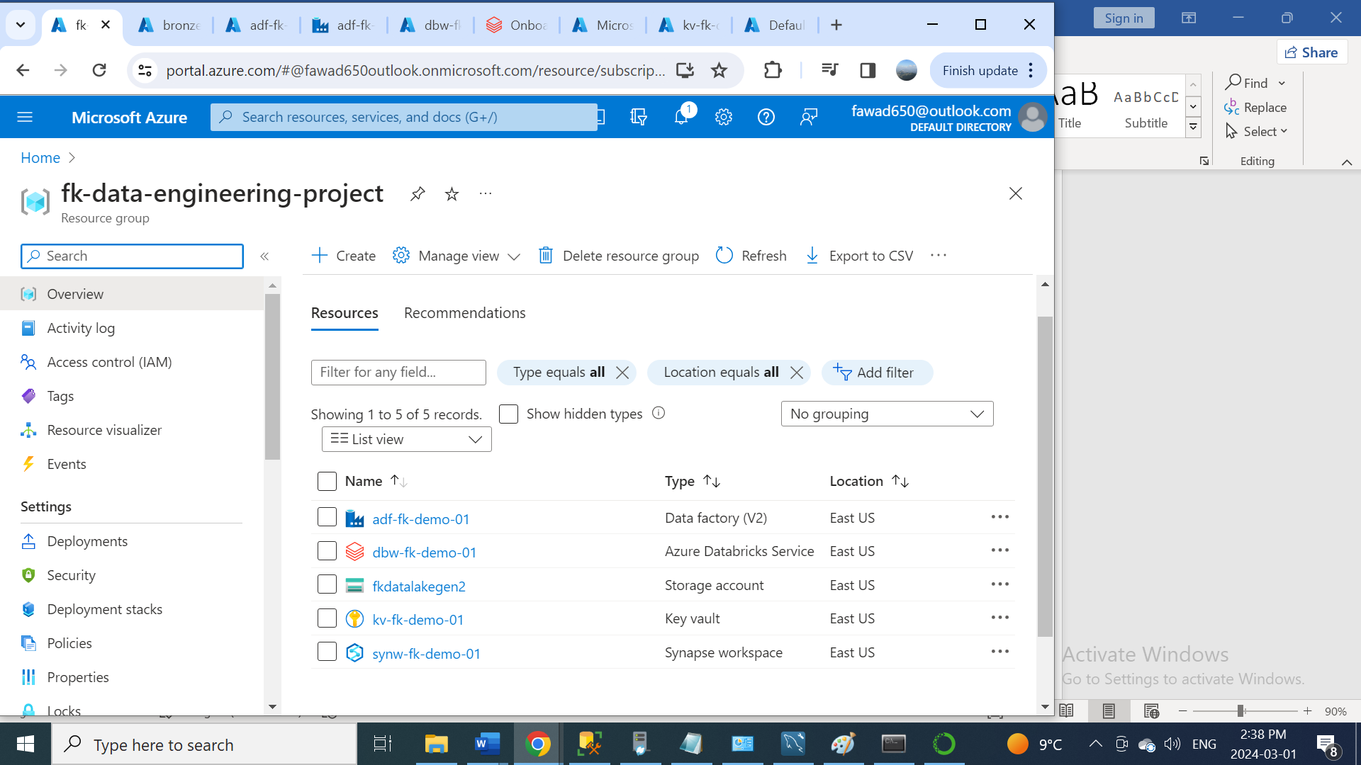

**Part 2: Data Ingestion**

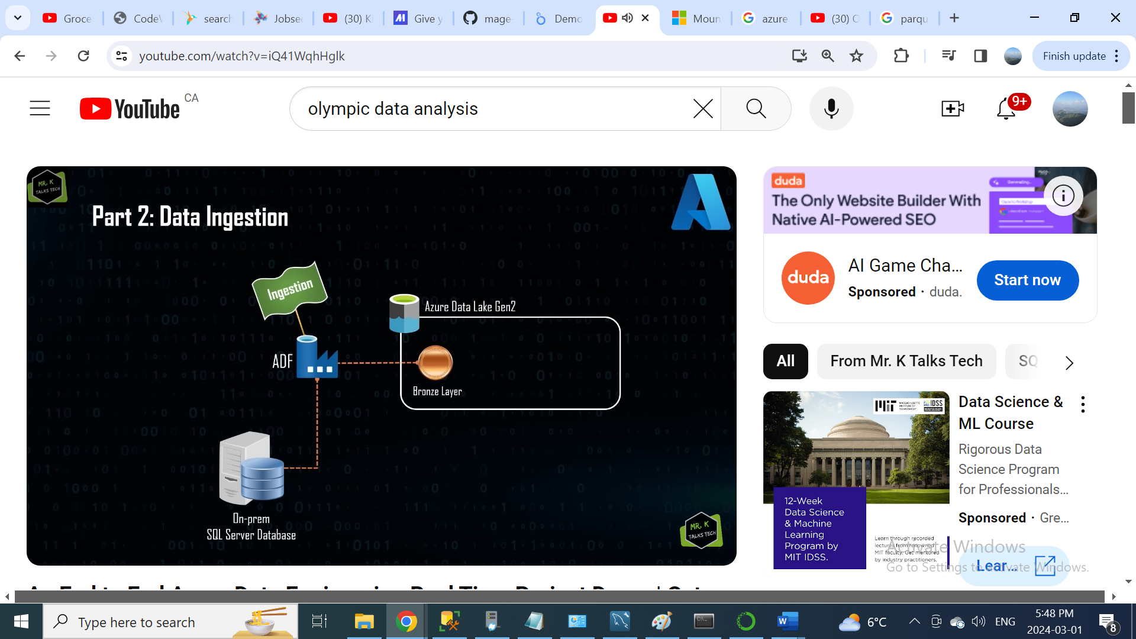

* Then open the database in SQL server. (AdventureWorksLT2017)
* Write a Query to get all the tables name start with (SalesLT)

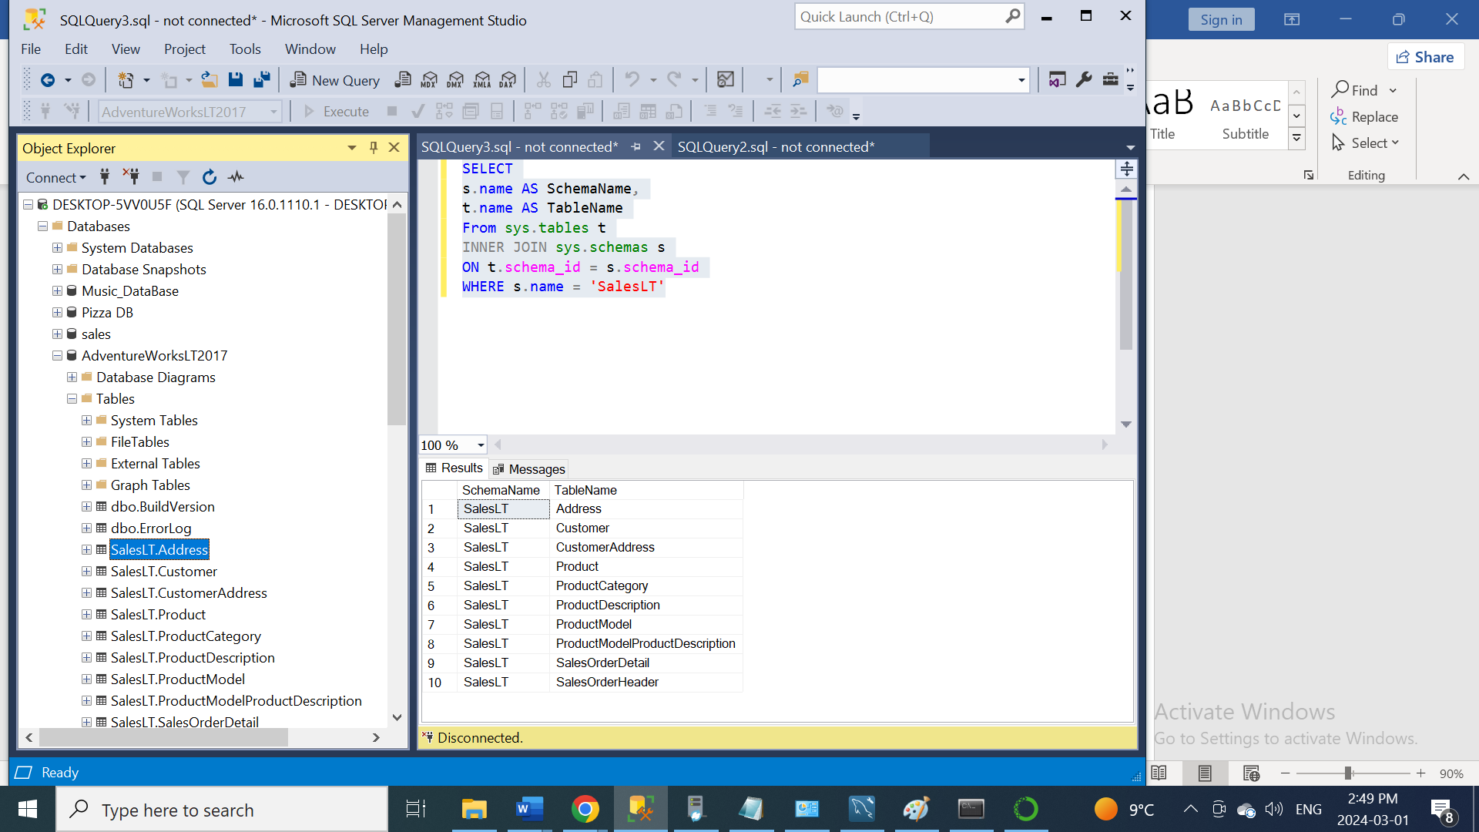

* After that, I create a pipeline in Azure Data Factory Studio (copy_all_tables)
* Then I created Lookup, ForEach, and ForEach Activity copy data.
* In Lookup I copied my Query, which I have written for table name. like this I will copy all tables together, I will not need to create copy data for each table separately.

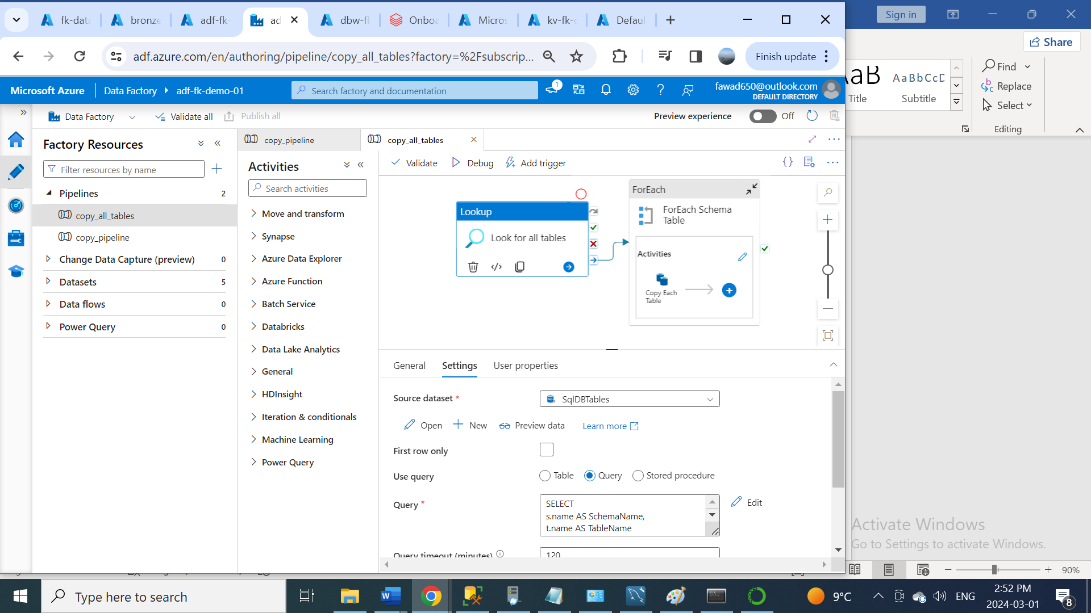

* In the Source dataset, I Created Connection Via Integration Runtime. Downloaded integration runtime and installed to create connection between my SQL server and Data factory.

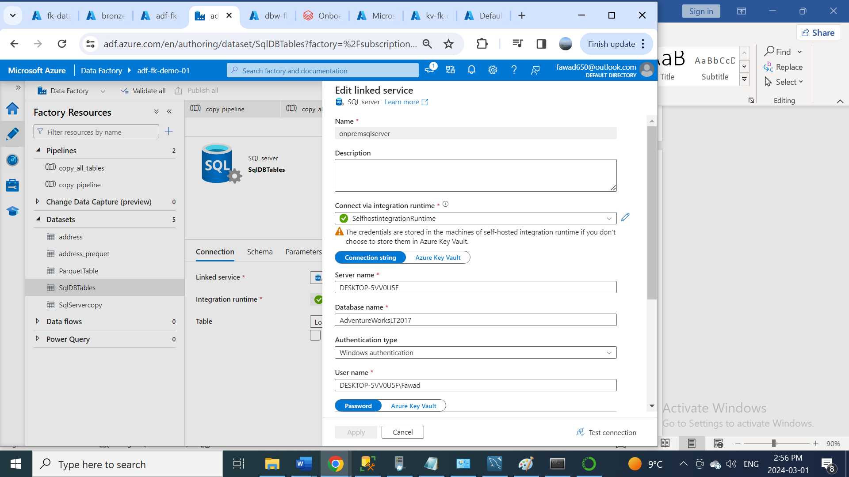

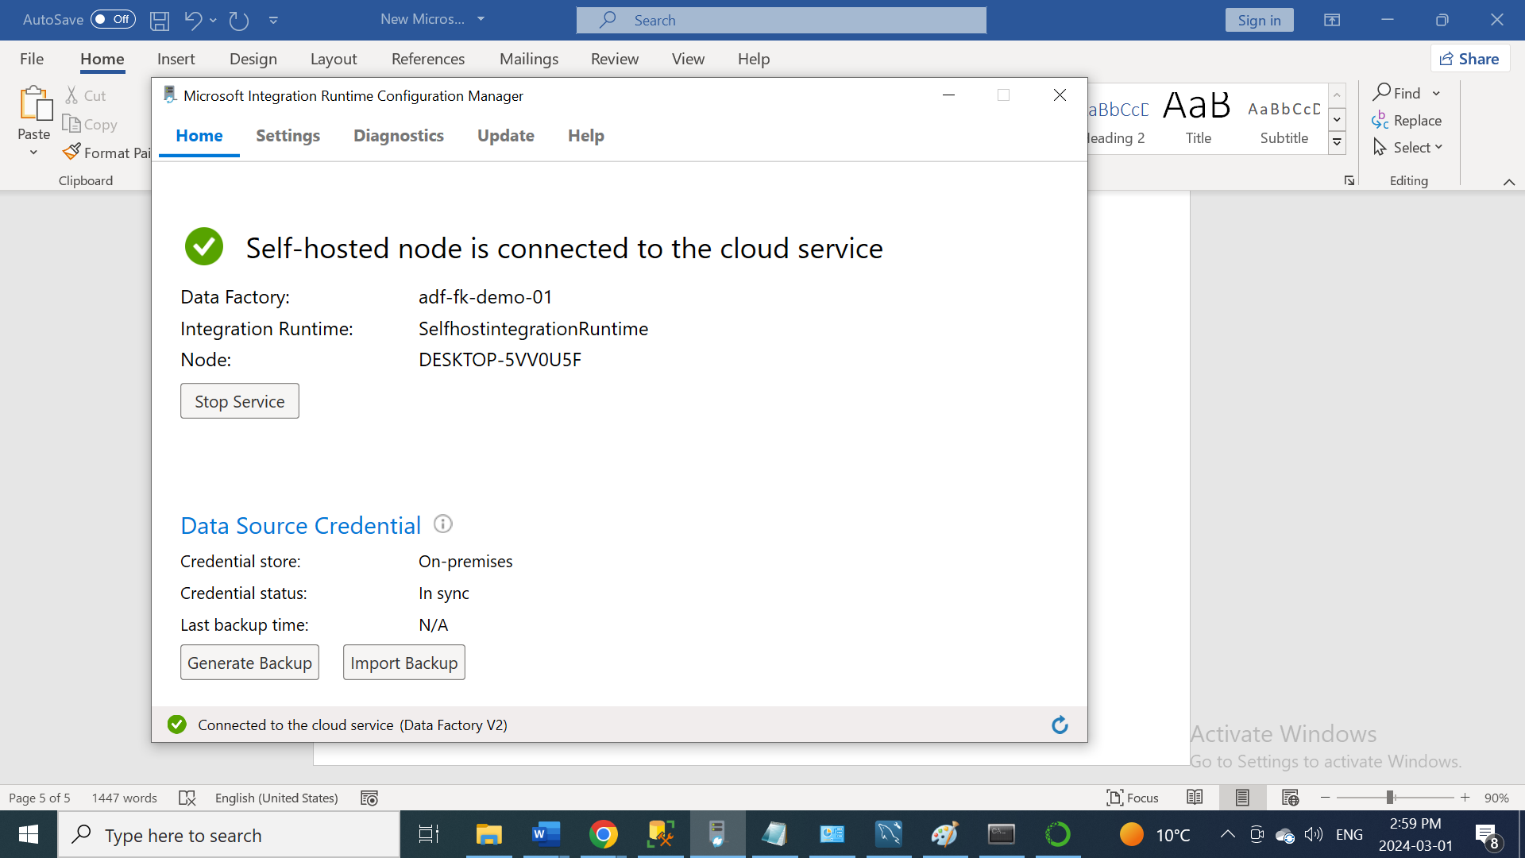

* In ForEach, I wrote a query in the sitting tab to get the values of the all Tablename

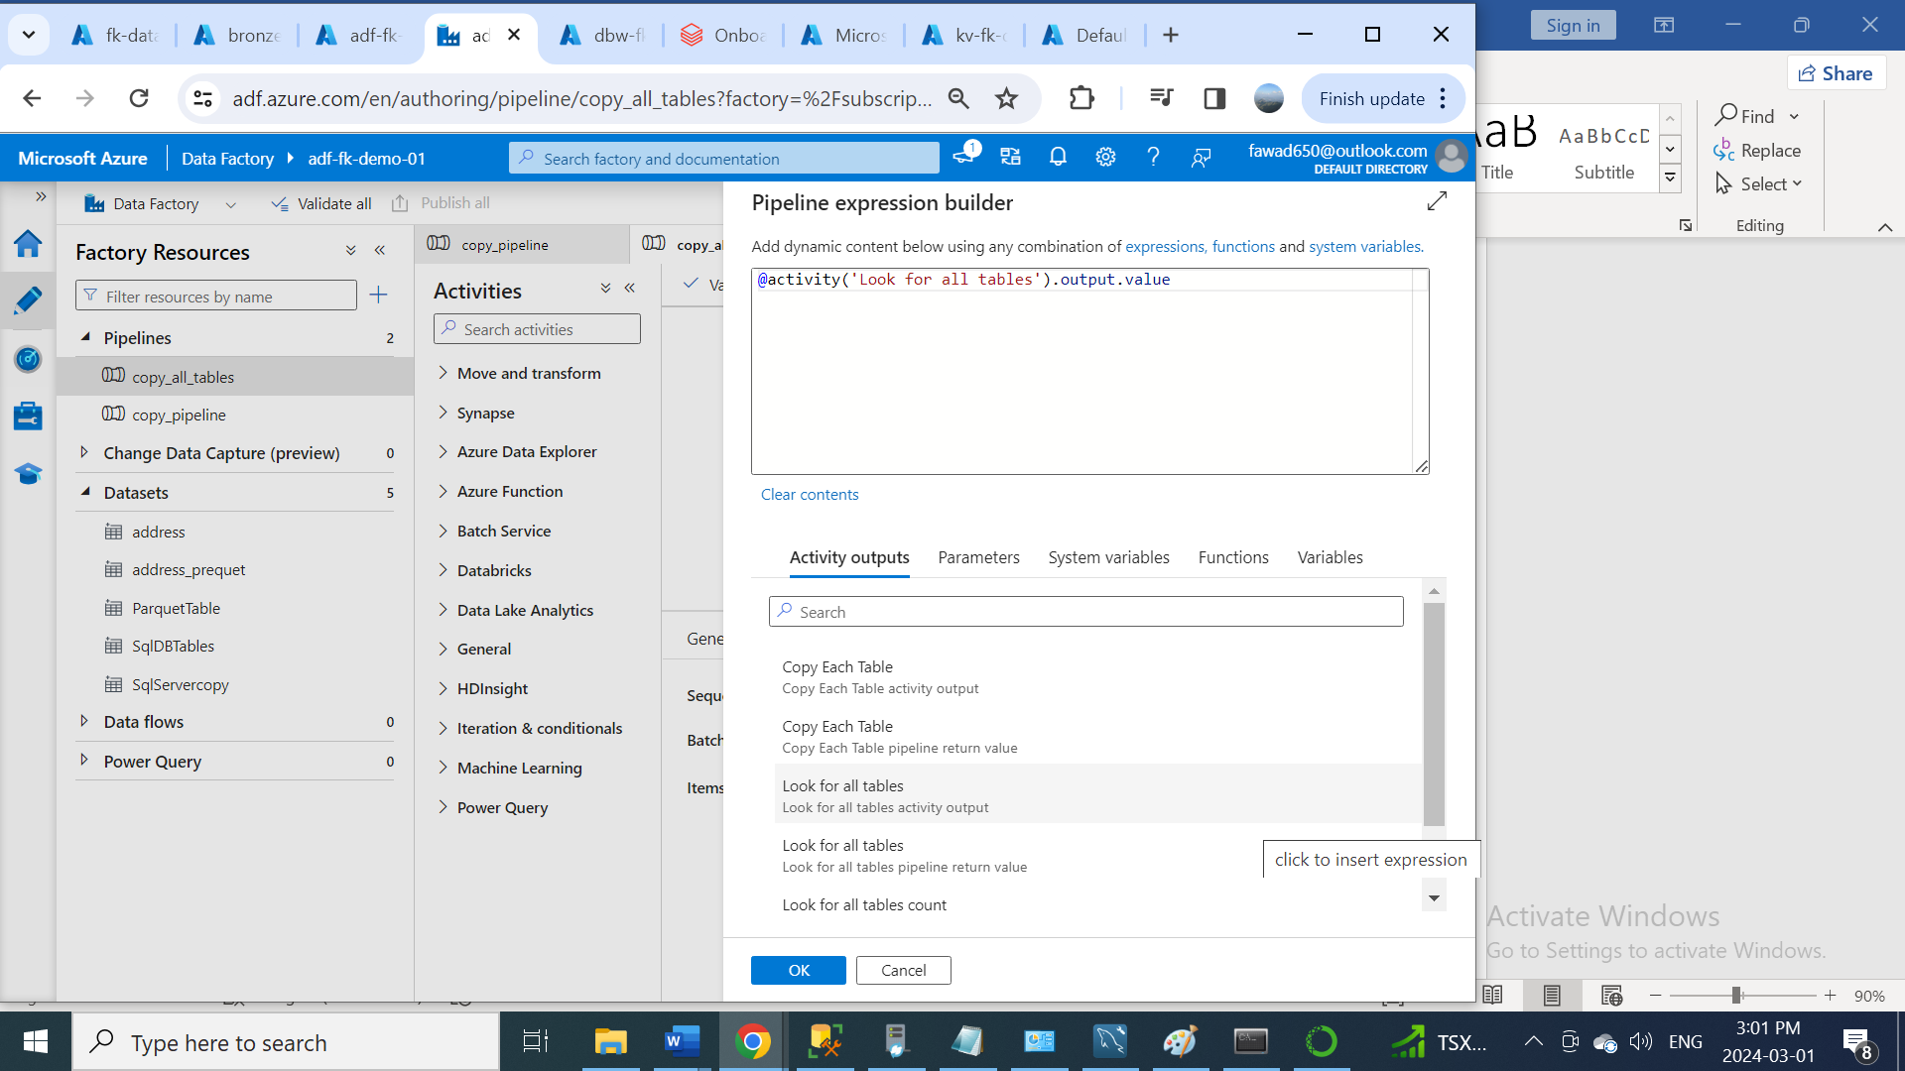

* Then In ForEach activity tab I created copy data. To copy all my table dates in my Azure Container.

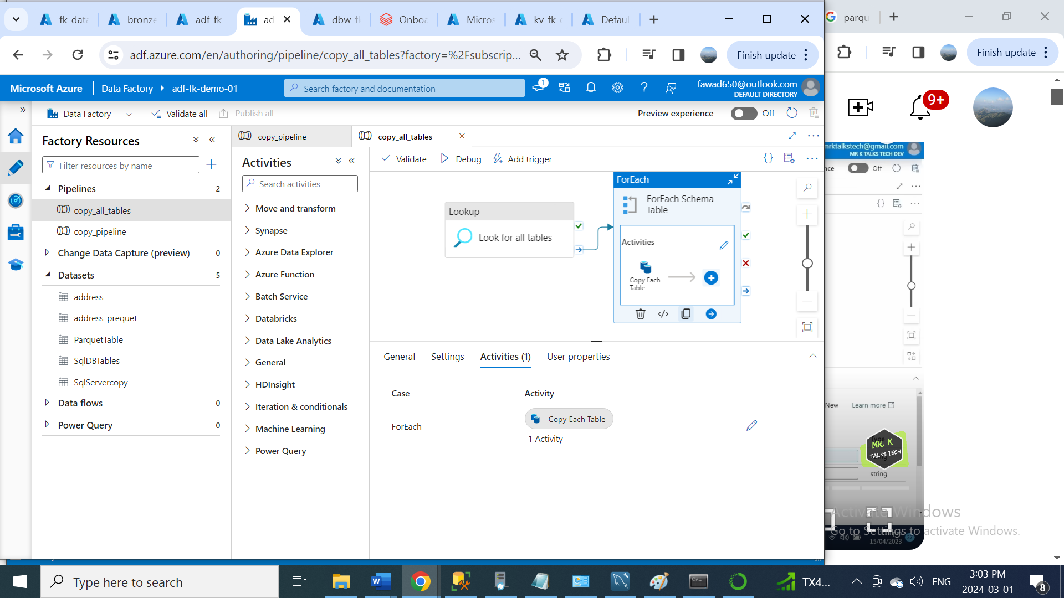

* Then in Copy data source, I wrote a query to select SchemaName and TableName from my main Lookup Query.

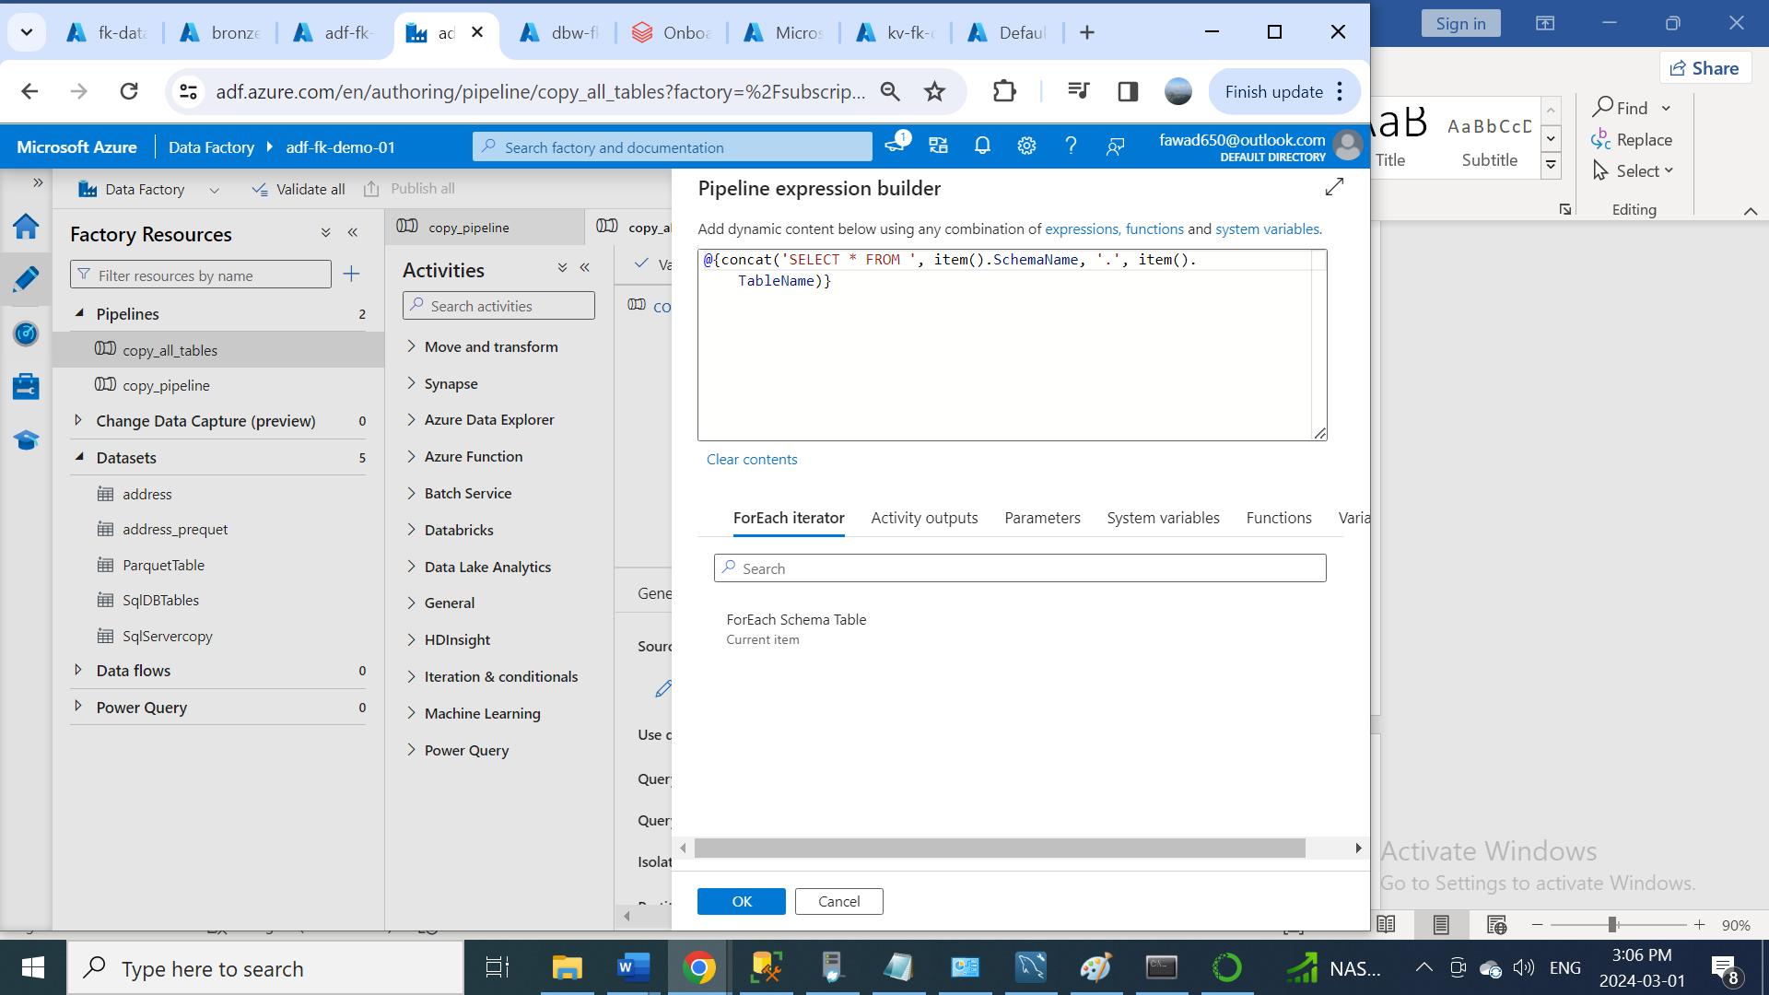

* In Copy data source I created connection between SQL server and data factory.
* In Copy data sink, first I created two parameters, one schemaname and other one tablename, to store the name of the source tables.

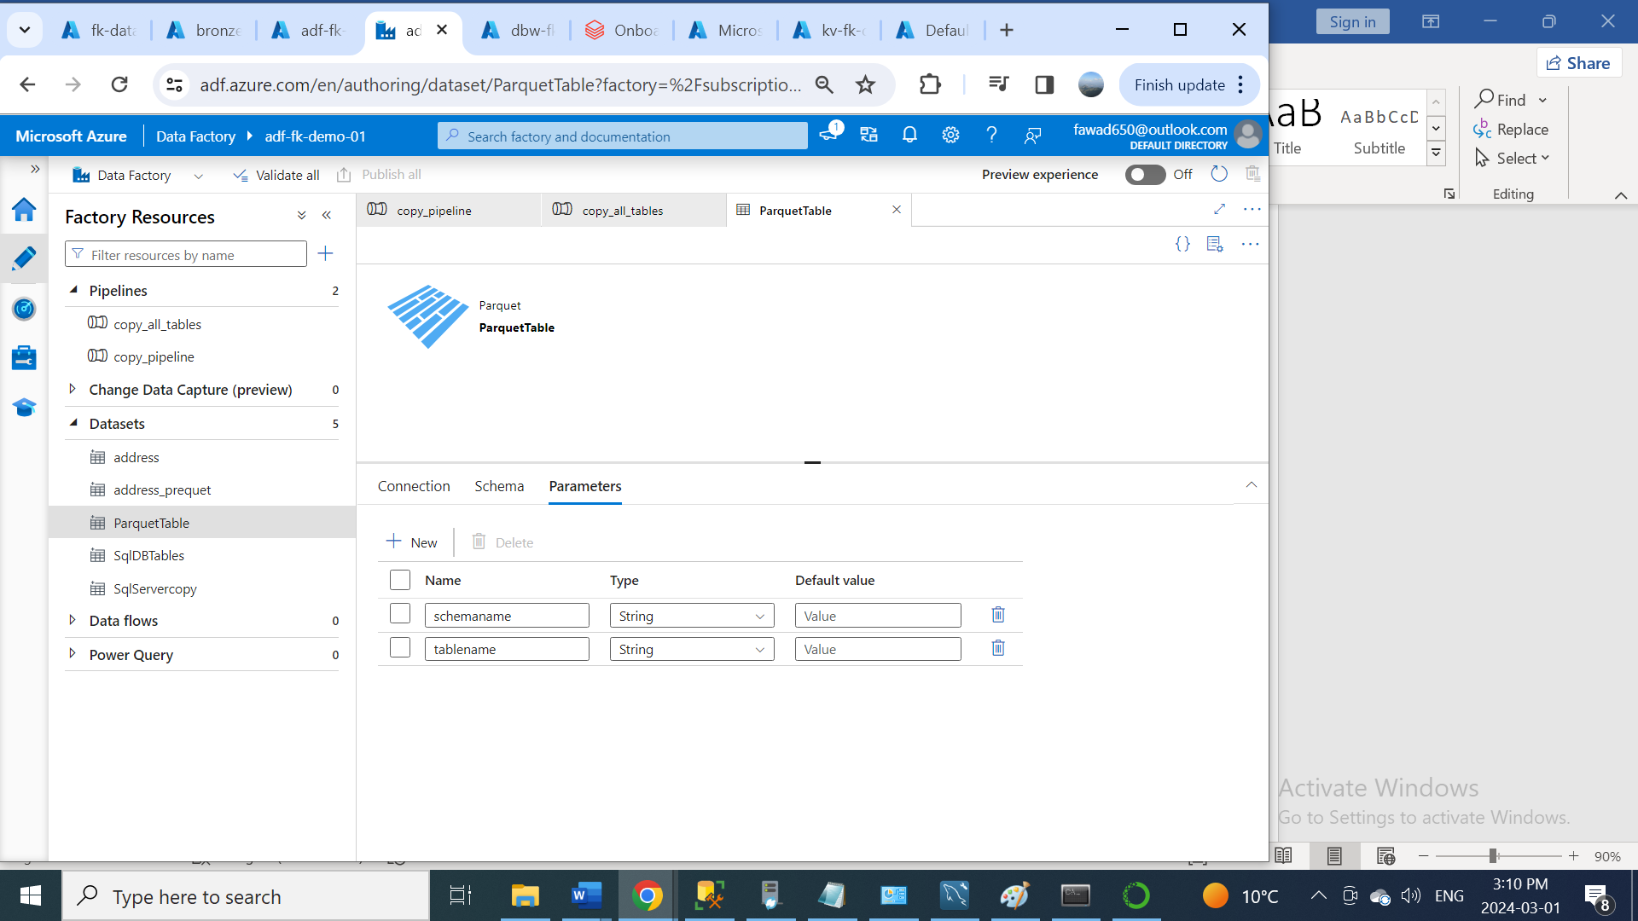

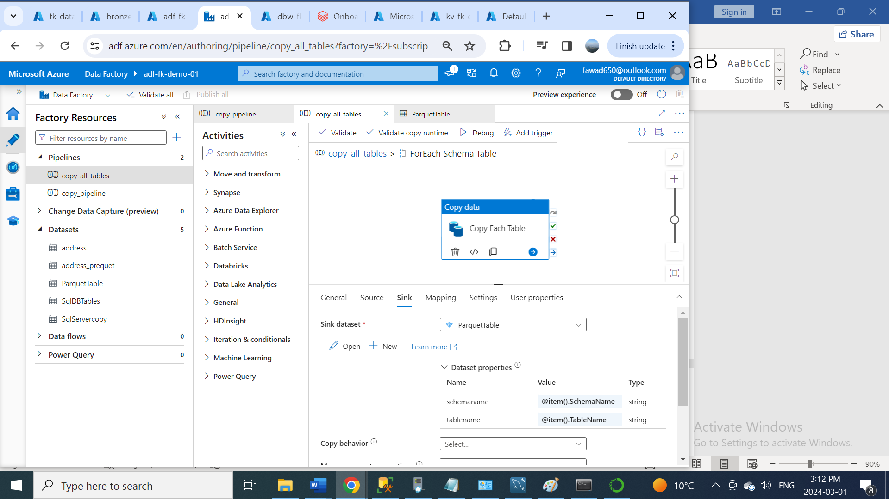

* Wrote query for both schemaname and tablename

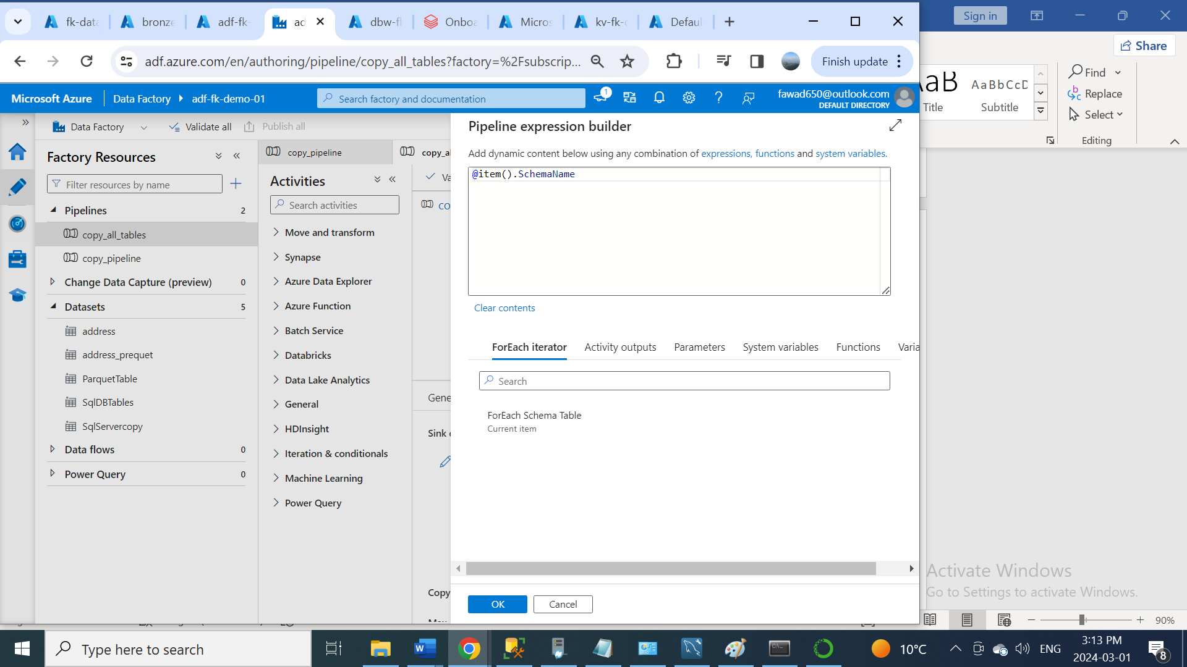

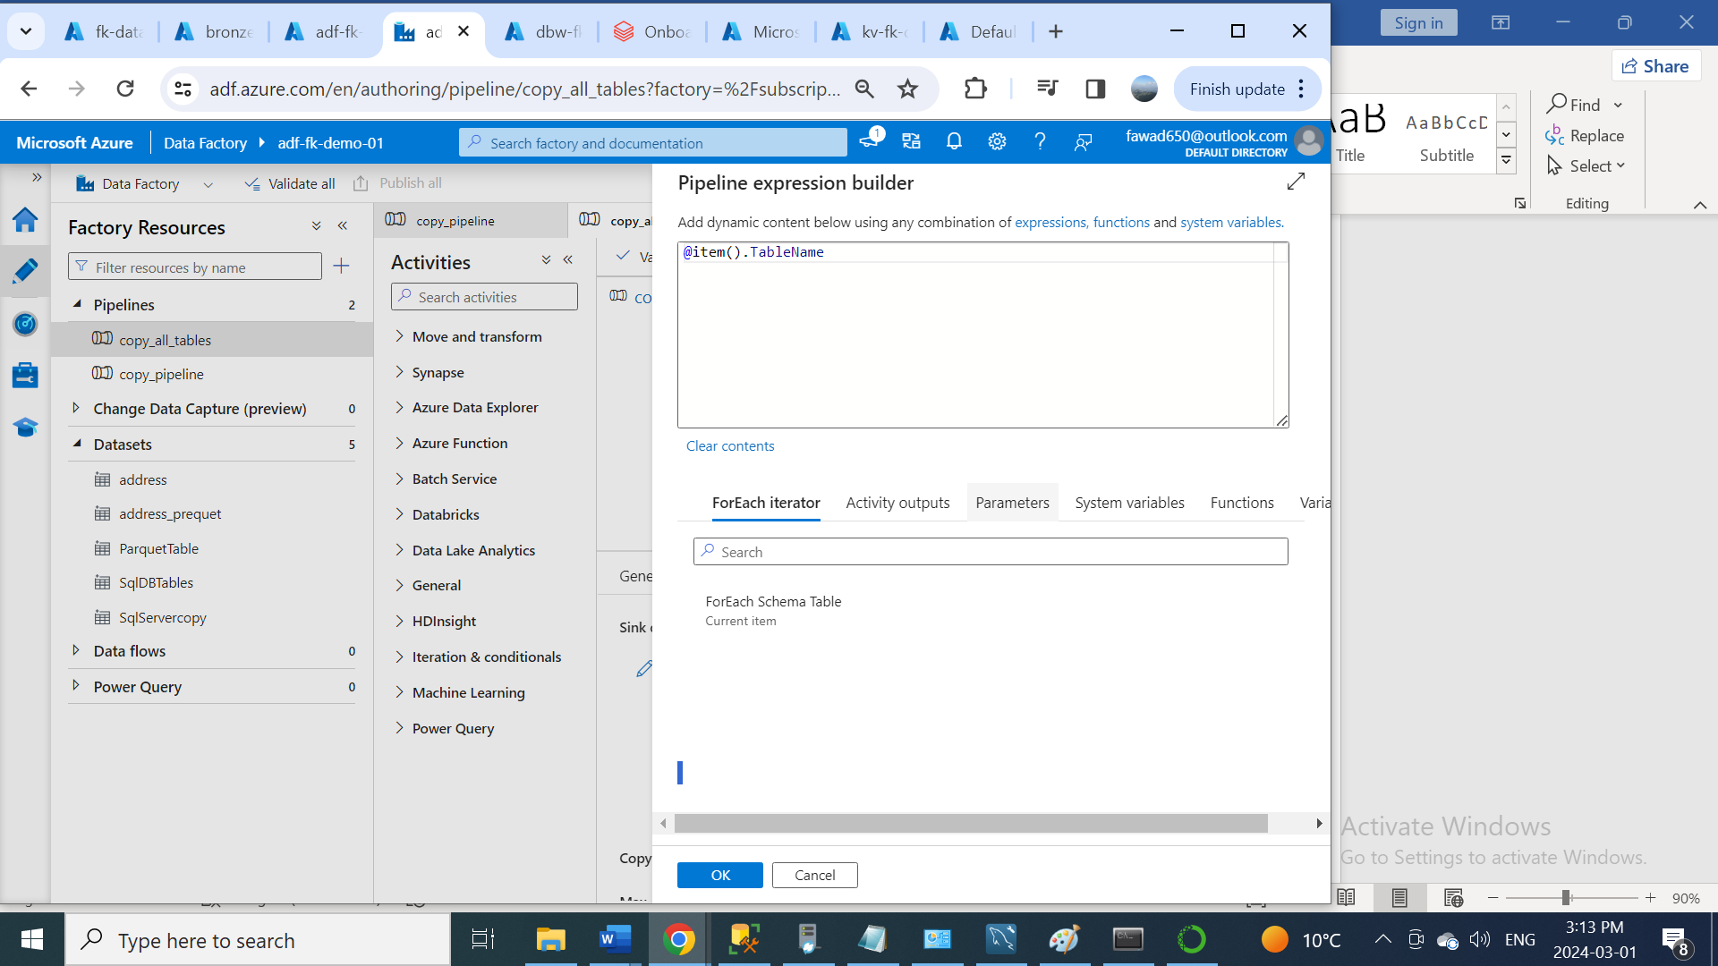

* Then I created a connection for data copy sink

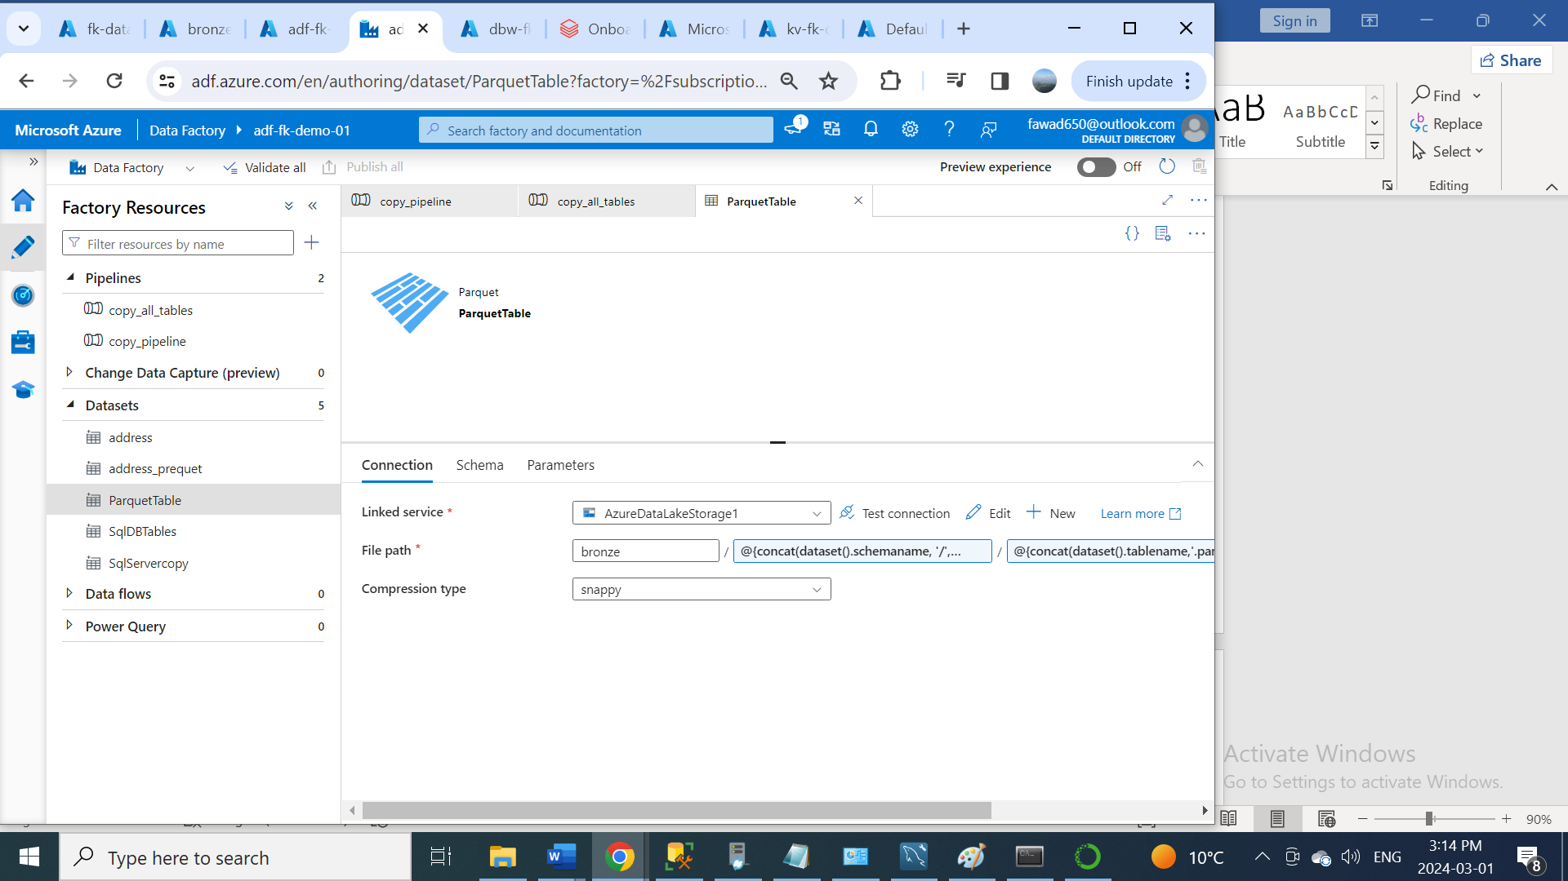

For Folder Structure bronze/Schema/Tablename/Tablename.parquet I wrote in file path to get the following folder structure. **e.**g., bronze/SalesLT/Address/Address.parquet

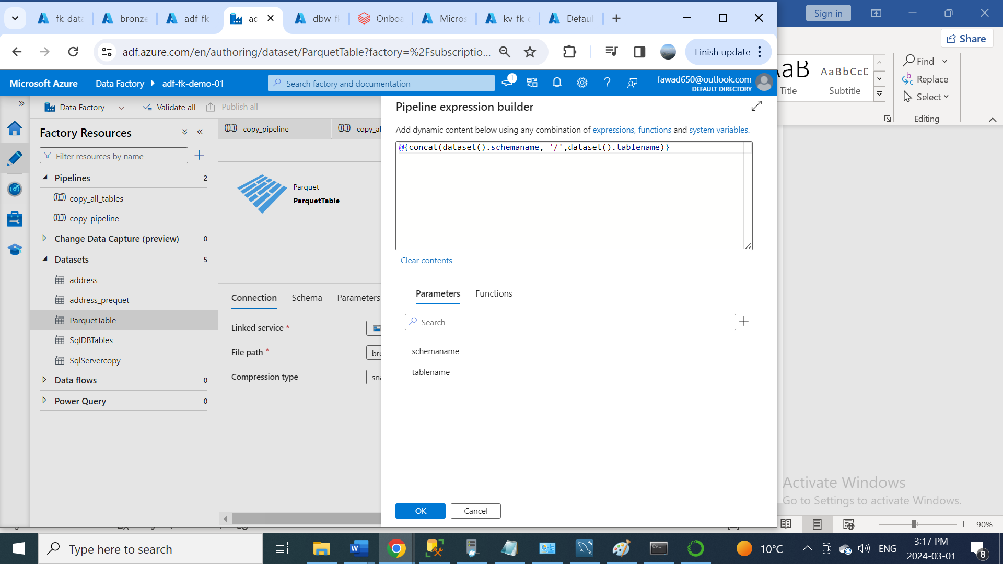

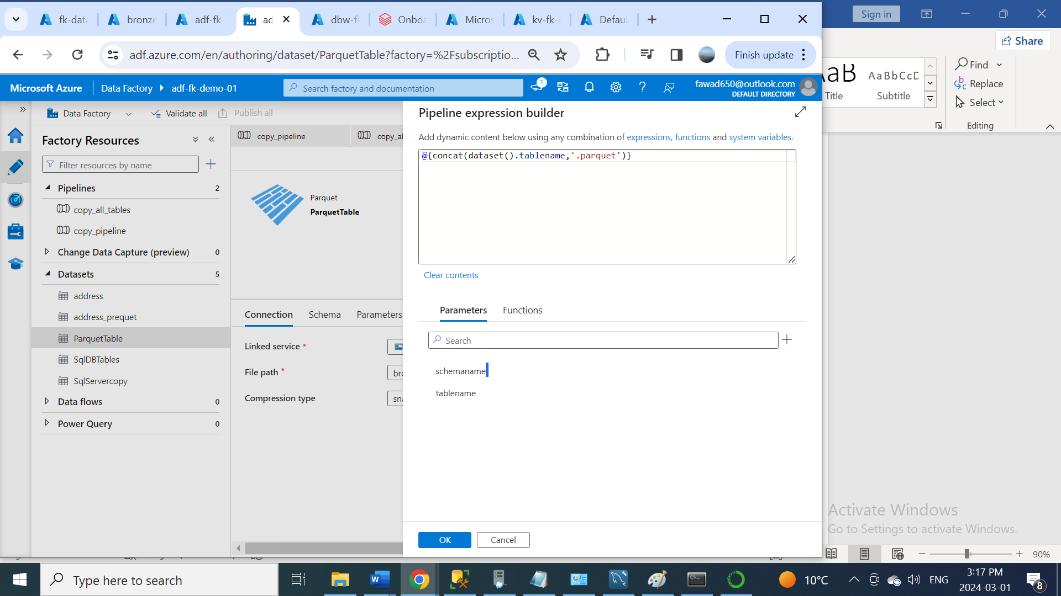

* After that, I clicked on publish all and debug my pipeline to copy all my data tables from SQL server into the Azure Storage Container (bronze).

**Part 3: Data Transformation**

* First, we will launch Azure Databricks workspace

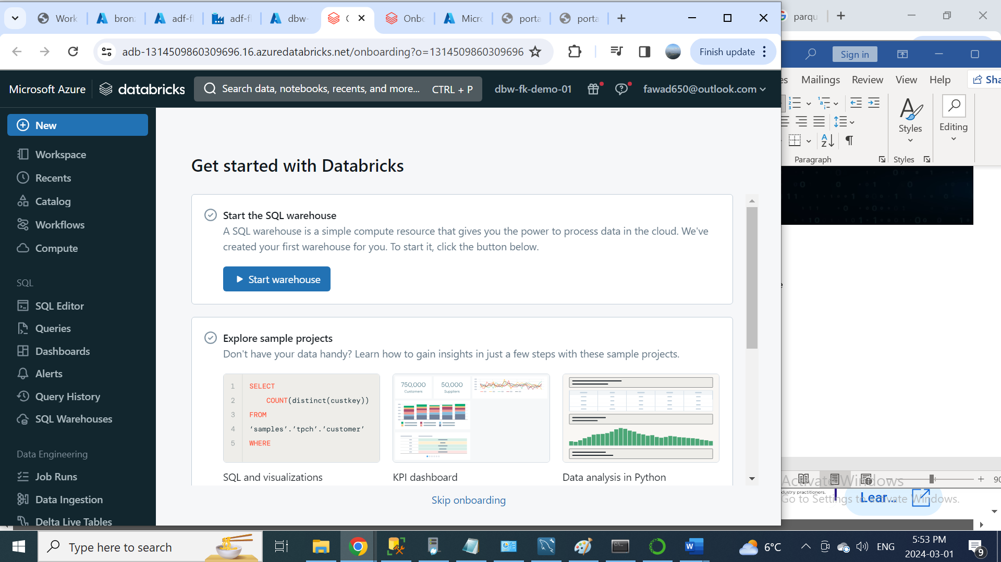

The Workspace tab is the tab, where we will be used using to create the notebooks to write the actual transformation logic.

The next one is Repos, so this is mainly used for git integration.

The next one is Recent tab; this tab is mainly used to identify what are the different notebooks that has been recently accessed.

A catalog contains schemas (databases), and a schema contains tables, views, volumes, models, and functions, so this is an interesting one. You can create a database and also tables, so you can access all these database and table using this tab

The most important one which is the compute tab, so we all know that databricks is mainly used for data transformation. So, to do any kind of data transformation, we need to have a compute power. So, to create this compute power, we need to use this compute app to create a cluster, so this is also called as spark clusters and we will be also creating a compute cluster to do all our data transformation logic in this project as well.

Workflow tab is mainly used to create the jobs using the notebooks that they have inside the databricks workspace, so we will not be using this workflow to create the jobs for the notebooks instead we will be using the Azure Data Factory pipelines to trigger all the notebooks that we create as part of this project.

* First click on compute and then click on create compute to create cluster.

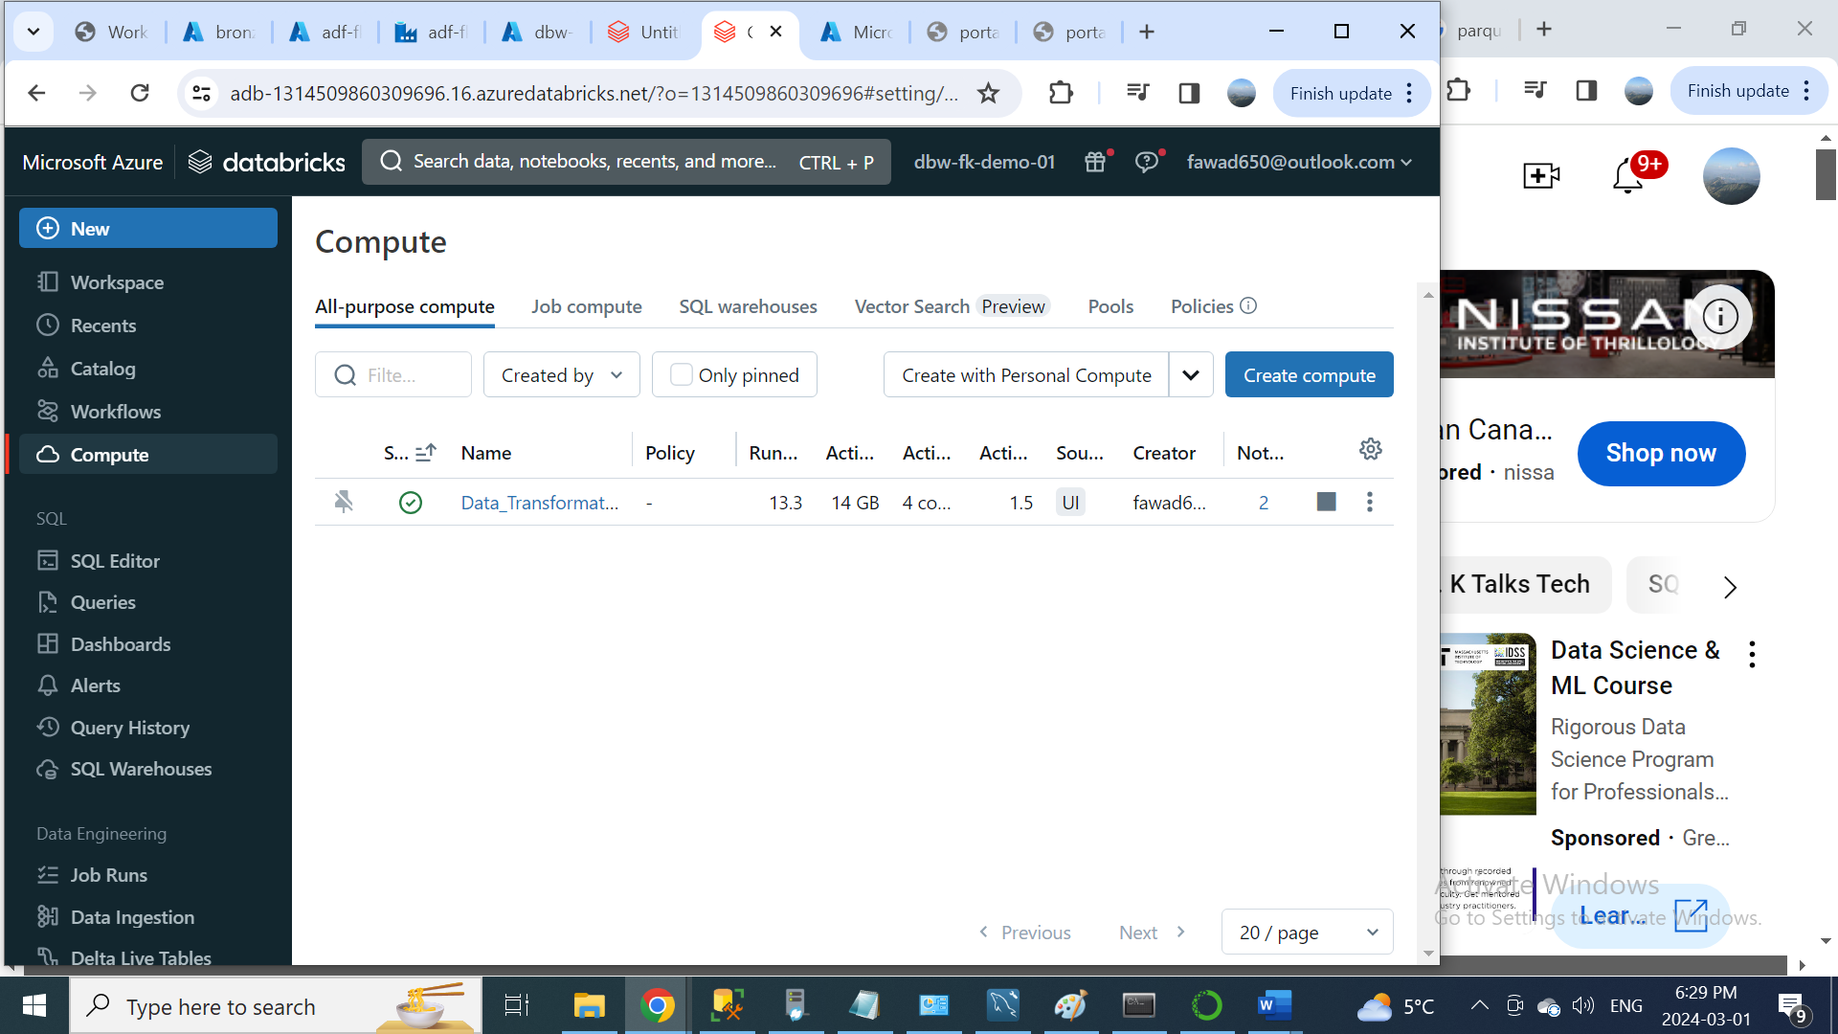

Create a notebook from workspace -> shared. To create this notebook, we will be using this notebook to actually Mount the storage account which is the data lake in Azure databricks. Now let’s see what is the code that we need to use in this notebook for that what I am going to do now is I’m just going to open a website, which is official Microsoft documentation website. So, this website will have information about how to mount a storage account with the Azure databricks using the credential pass through as you can see here, we have section called mount data lake storage to DBFS using credential passthrough.

<https://learn.microsoft.com/en-us/azure/databricks/archive/credential-passthrough/adls-passthrough>

So, this is what we need to do in this notebook, so for that what I am going to do to copy the python code and paste it over there in notebook. In the code we need to update the container name and storage account name for source. Then update the mount-name for mount point. Then run the code.

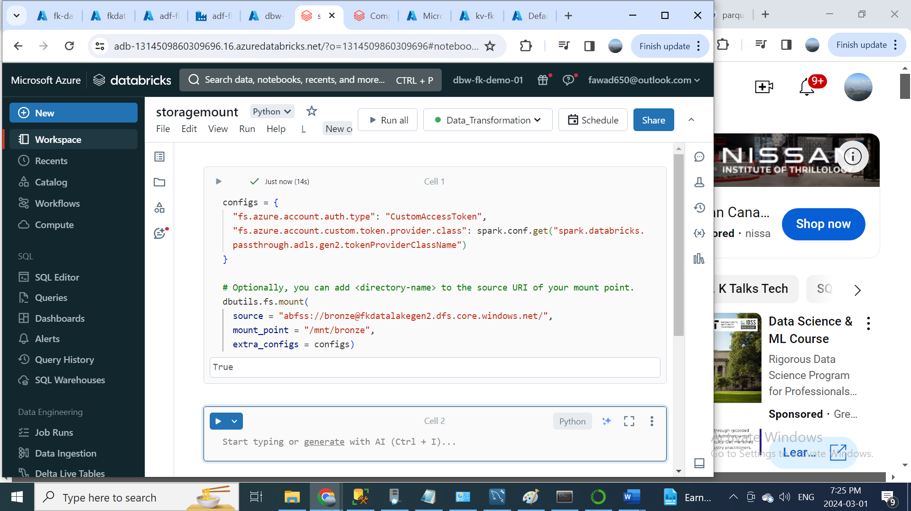

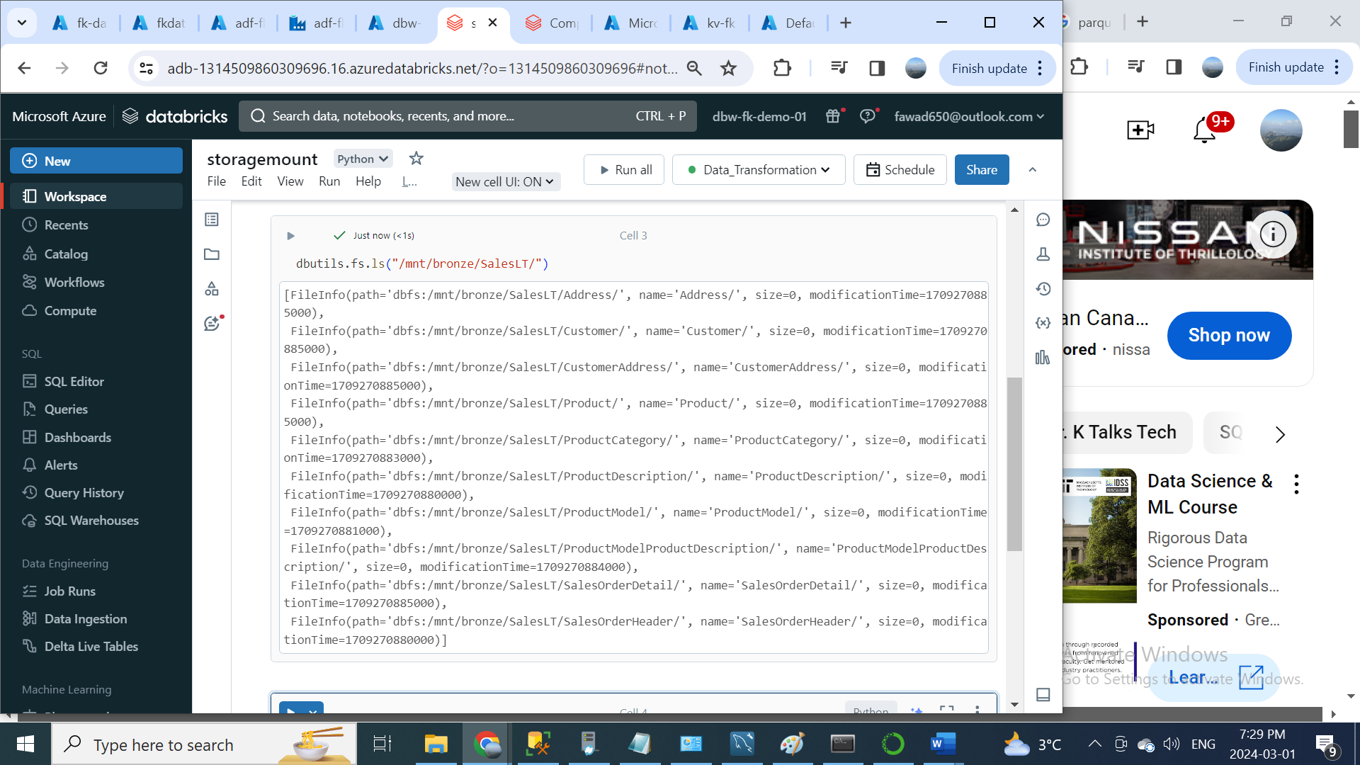

**Part 3: Data Transformation:**

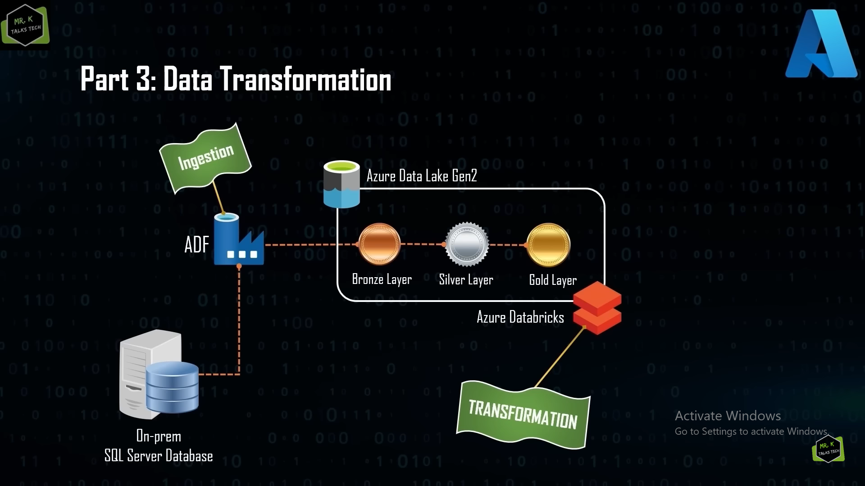

We did two level transformation on being the date format transformation and other one in the column name transformation. So, this is the final data that is going to be loaded into the database and also used for reporting. Now we have completed the data transformation logic.

As you can see here, we have two notebooks one is the bronze to silver and other one is silver to gold and as you can see here the other notebook which is storage mount notebook, so this notebook is just mounting the data lake. We have to just run that once and we don’t have to run that as a job, but the other two notebooks which bronze to silver and silver to gold needs to be run as a job, so for that what we are going to do is, we are going to use Azure data factory pipelines to create a notebook activity to run this as a job. Let’s see how we can do that.

Before going to Azure data factory to create the pipelines for these two notebooks, what I have done is, I have updated these two notebooks to remove all the unwanted codes. We are going to use such a data factory to create the pipelines to just run these two notebooks.

In Azure data factory this is the pipeline, that we have created before, which is copy all tables and we need to update this pipeline to include the database notebook, so for that what we have to do is we need to establish a connection between the usual data bricks and the Azure data factory. So, we all know that to make that connection possible, we need to create a link service connection. So, I am just going to the manage tab and under this linked service option, we can create a new link service connection for databricks, so for that I am just going to click on the new button over there and in the search box I am going to type an Azure databricks and if I just I switch back to compute here and as you can see here the databricks. We have to click on that and hit continue.

We need to choose the integration runtime, so we have two options, option one is the auto resolve integration runtime and other one is self-host integration runtime. We need to choose the auto resolve integration runtime, since the Azure databricks is a cloud-based resource and after choosing the integration runtime. Select Azure Subscription and Databricks workspace. Next select cluster (Exiting interactive cluster). Select Authentication type (Access Token). To create the access token, we need to go to Databricks workspace and click on the username on the top right, there will be an option called user setting, so I am going to click on that user settings and then click on Access tokens, after that click on Generate new token. Write the comment and click on generate. Then go to key vault and generate the secret key for the access token. Then select access token via Azure key vault. Then select cluster.

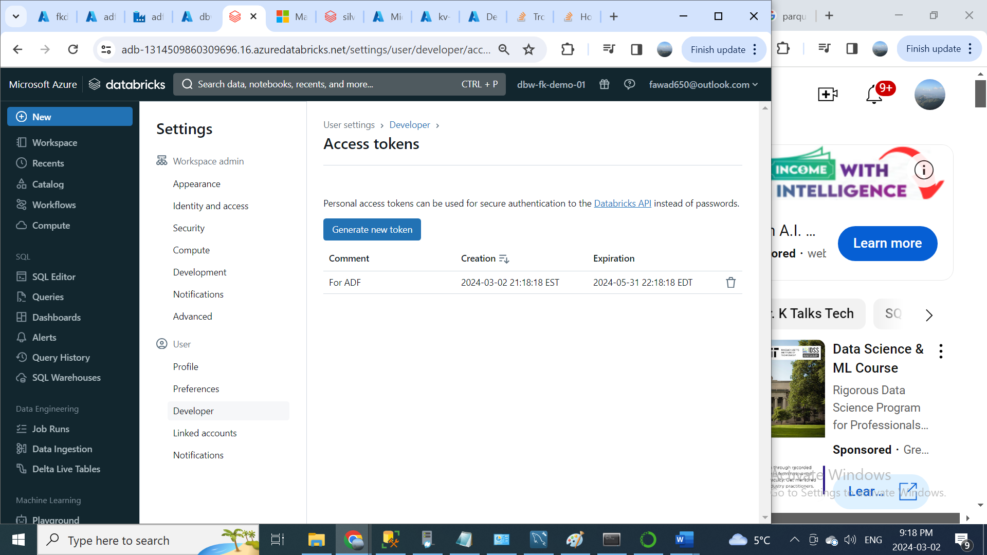

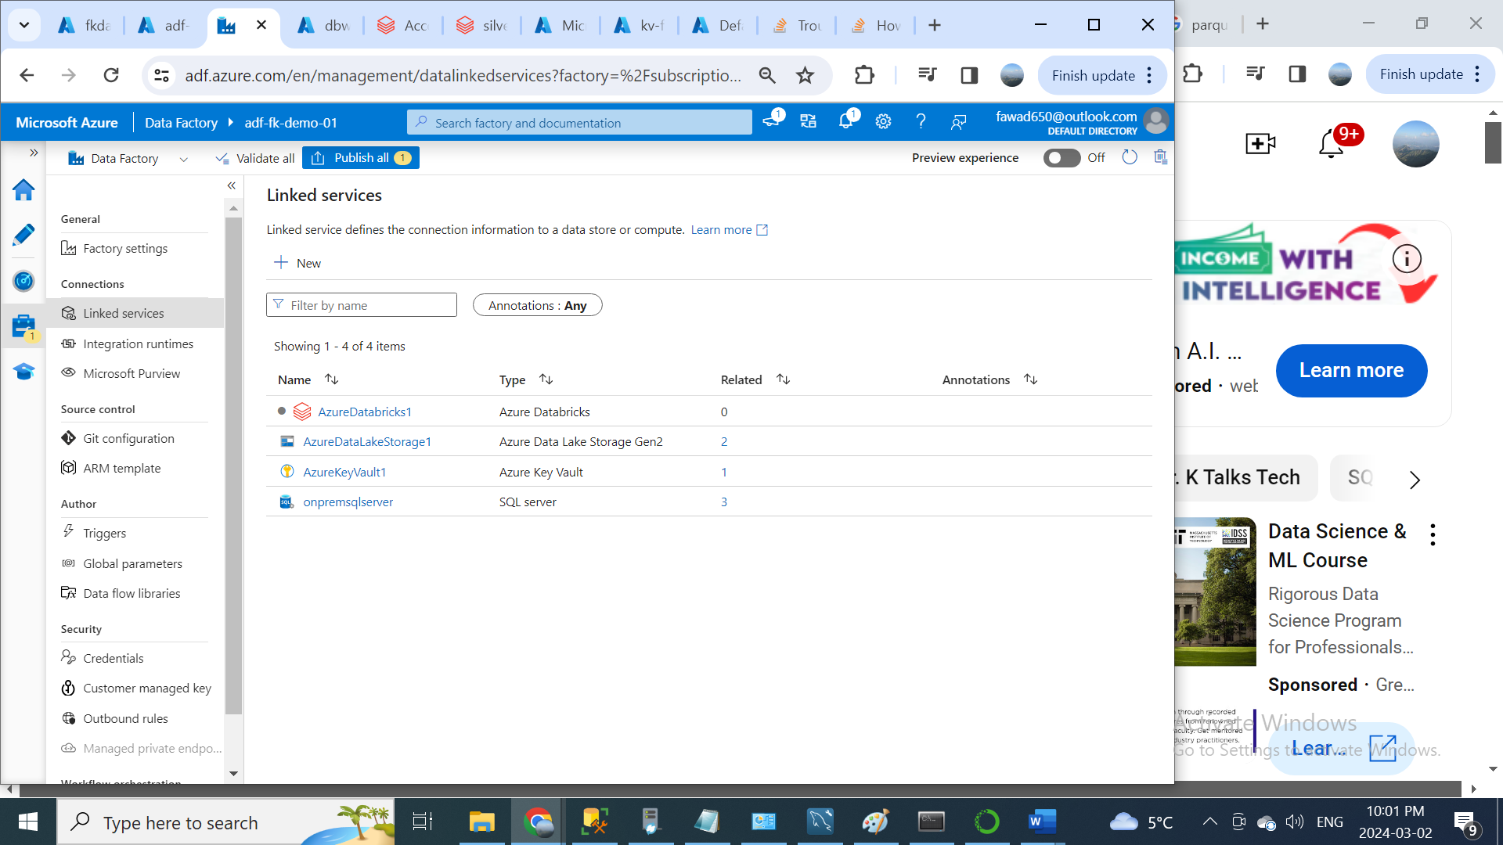

Then click on the publish button to save the changes.

Now I am going to create two new activities, one for bronze to silver and the other one silver to gold. So, for doing that, what I am going to do is, I am going to create an activity called notebook activity. Select databricks notebook activity.

In notebook activity, first activity is for bronze to silver and other one is for silver to gold. Then for these activities, in azure Databricks tab select your databricks and in settings tab select your notebook path for both activities. Then click on publish all, to save all changes.

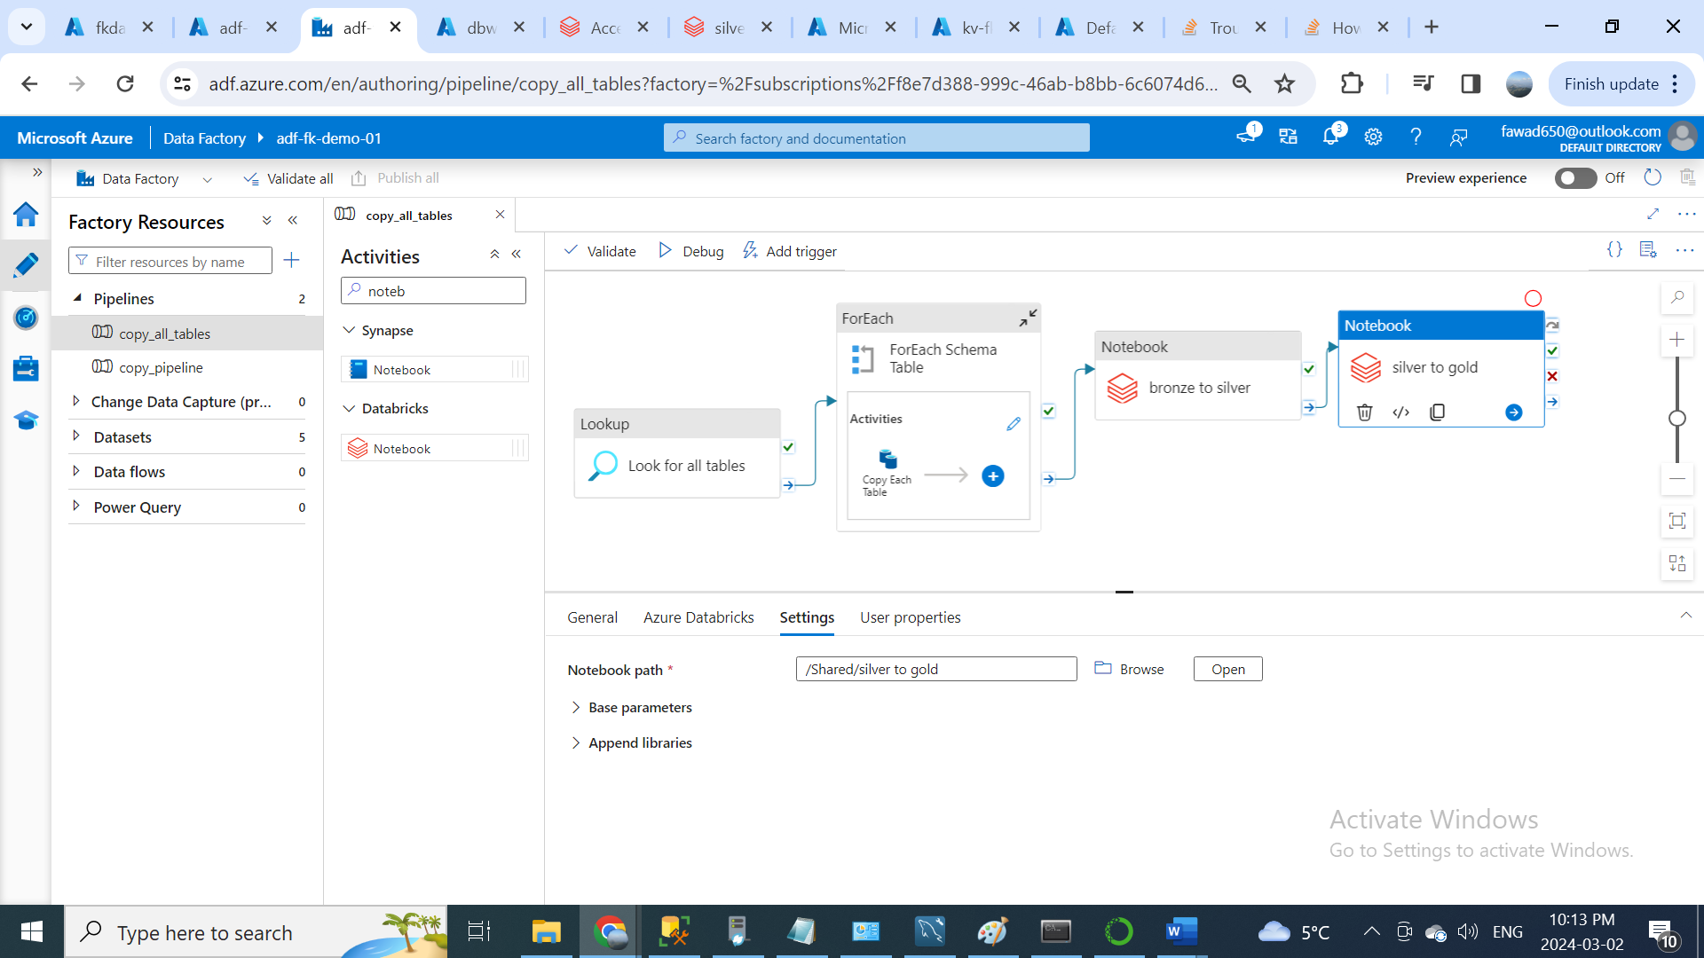

**Part 4: Data Loading:**

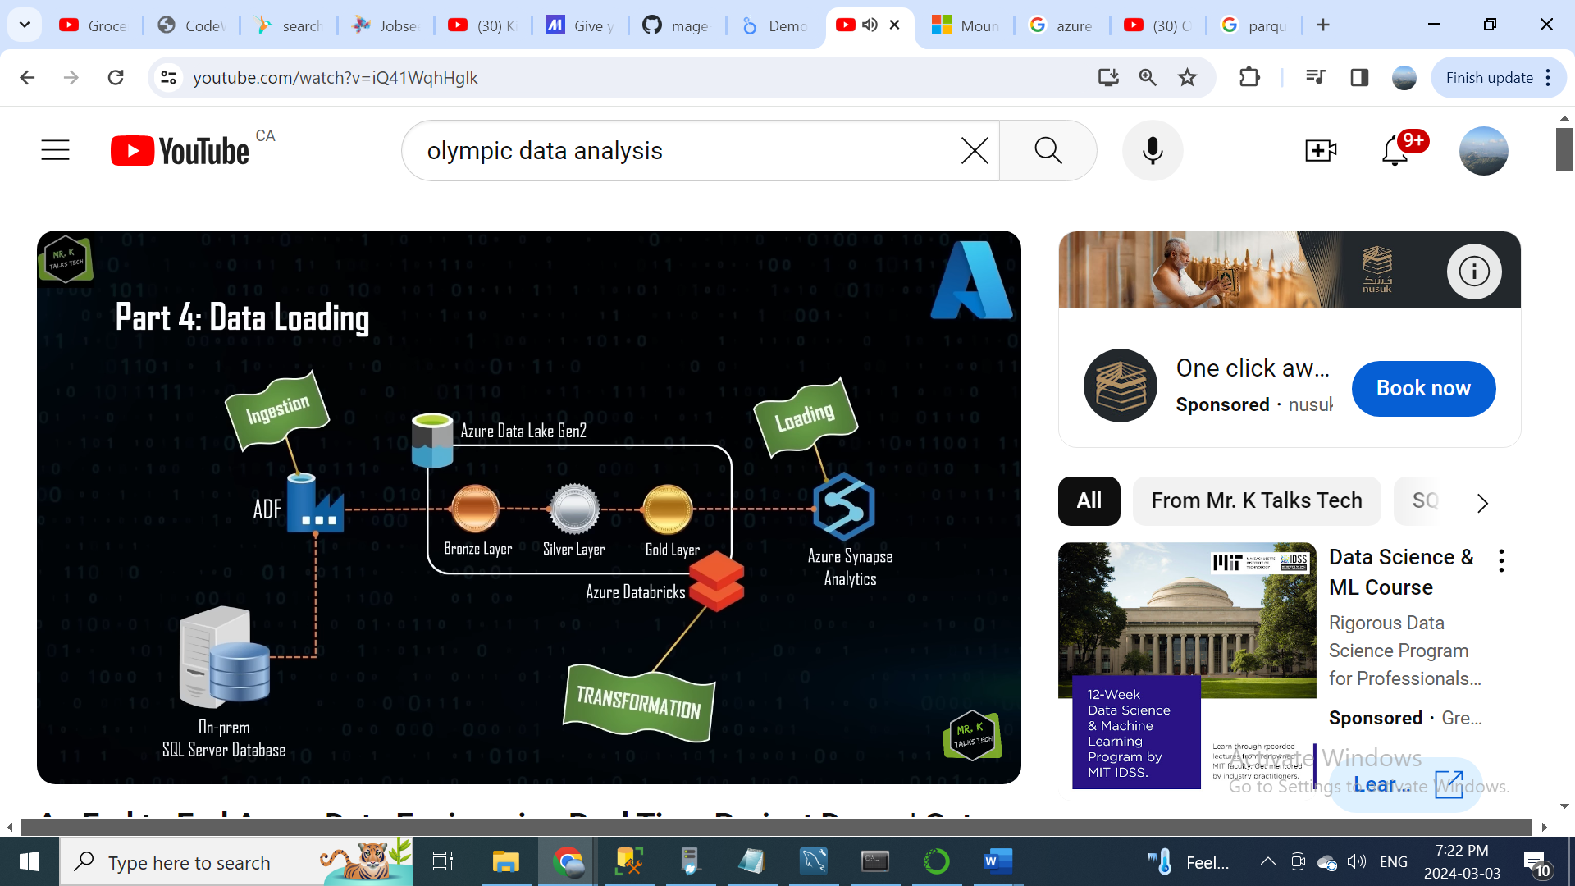

First open the Azure Synapse Studio.

As you can see here the layout is kind of similar to data factory. So, the main reason for this is Azure Synapse Analytics is built on top of Azure Data Factory, pretty much most of the things that you can do with Azure Data Factory, can also be done using Azure Synapse Analytics. For example; there is a tab called integrate tab, which is similar to the Azure Data Factory one, where you can create pipelines activities and all other stuff also. You have monitor tab and manage tab, where you can create link service connection, integration runtime, triggers and all other stuff similar to Azure data factory. Apart from this, there are two additional features in Azure Synapse Analytics, so if you see in the left side. We have tab called data tab and the other tab is develop tab. Using data tab, we can create database in Azure Synapse Analytics, so this feature is not available in Azure data factory. And the next one is develop tab, so using develop tab you can actually create the SQL script or notebooks, so similar to how we have created notebooks in databricks to do all the transformation. you can also use Azure Synapse Analytics to create a notebook for data transformation work, so basically you can think of Azure Synapse Analytics as a combination of both Azure data factory and Azure databricks. Using Azure synapse analytics, you can create pipelines activities which acts as an orchestrator also you have the spark capabilities where you can create notebooks for transformation similar to databricks.

So, now let’s create a database in Azure Synapse Analytics, so for that what I am going to do is, I am going to the data tab and inside the data tab I am going to click on the plus icon, you will be finding something called SQL database, which is Azure SQL database. So, let’s create this as part for this project. I am going to click on that, as you can see here. There are two types of SQL database pool type, one is Serverless and other one is Dedicated. First, let’s see what is the difference between Serverless SQL database and Dedicated SQL database. So, in simple terms you can say that the Serverless SQL database is mostly used in the smaller workloads, whereas the Dedicated SQL database is used to the scenarios which requires higher workloads, so the other differences are the Serverless SQL database used the built-in pool to process the data, when you actually create the synapse analytics you get a default built-in pool the Serverless SQL database just uses that pool. Whereas in Dedicated SQL database you need to create an external compute so similar to how we created a cluster in Azure databricks. We need to create this dedicated pool for the database to process the data, so we can create this Dedicate pool with a higher configuration which increases the performance of the data processing. Whereas in Serverless SQL database you don’t have any control over that and hence the performance might be low. But in the cost wise the Dedicate SQL database is much expensive compared to the Serverless SQL database. Another key difference between these two databases, you can pause the Dedicated SQL pool, if it is unused, but in Serverless SQL database you can’t pass the built-in SQL pool, so for example what I will do is, I will just cancel this and I will go to the manage tab and under manage tab, you will be finding something called SQL pools, so inside this you will be finding the built-in Serverless SQL pool as you can see here the status for this pool is online, which means that this built-in pool is going to be online all the time. So, this gets generated when you actually create the synapse workspace. We can use this built-in SQL pool in the serverless SQL database to query all the tables in the database. As discussed before the dedicate SQL pool doesn’t get generated by default, to create a new dedicated SQL pool, what you can do is, you can click on this new button. As you can see here a new dedicated SQL pool can be created using this option and finally one of the most important differences between dedicated SQL database and serverless SQL database, in serverless SQL database we are just using the compute whereas in dedicated SQL database we are using both storage and compute. So, what I mean by that is for example now we have all the data in the gold container in the data lake. If you are using serverless SQL database the data will still exist in the data lake, but we can just use the built-in serverless SQL pool to query the data directly from the data lake itself, which means that it just uses the compute and the storage is in data lake itself. Whereas in the dedicated SQL database the data in the gold container should be completely loaded into the database and the data can be queried using the dedicated SQL pool, which means that it uses both the storage and the compute power.

In this project we are going to go with the serverless SQL database, since the data that we are dealing is very less amount of data and also the data is properly structured in the data lake in the gold container. I would say using the serverless SQL database would be the most optimal solution for this project.

After selecting the serverless SQL database, we need to now enter the database name, I am going to give you a database name called gold_db. Since, we are just loading the data which is in the gold container, let’s create this database with this name. After giving the name, we can just click on this create button to create the database. The database has been created now.

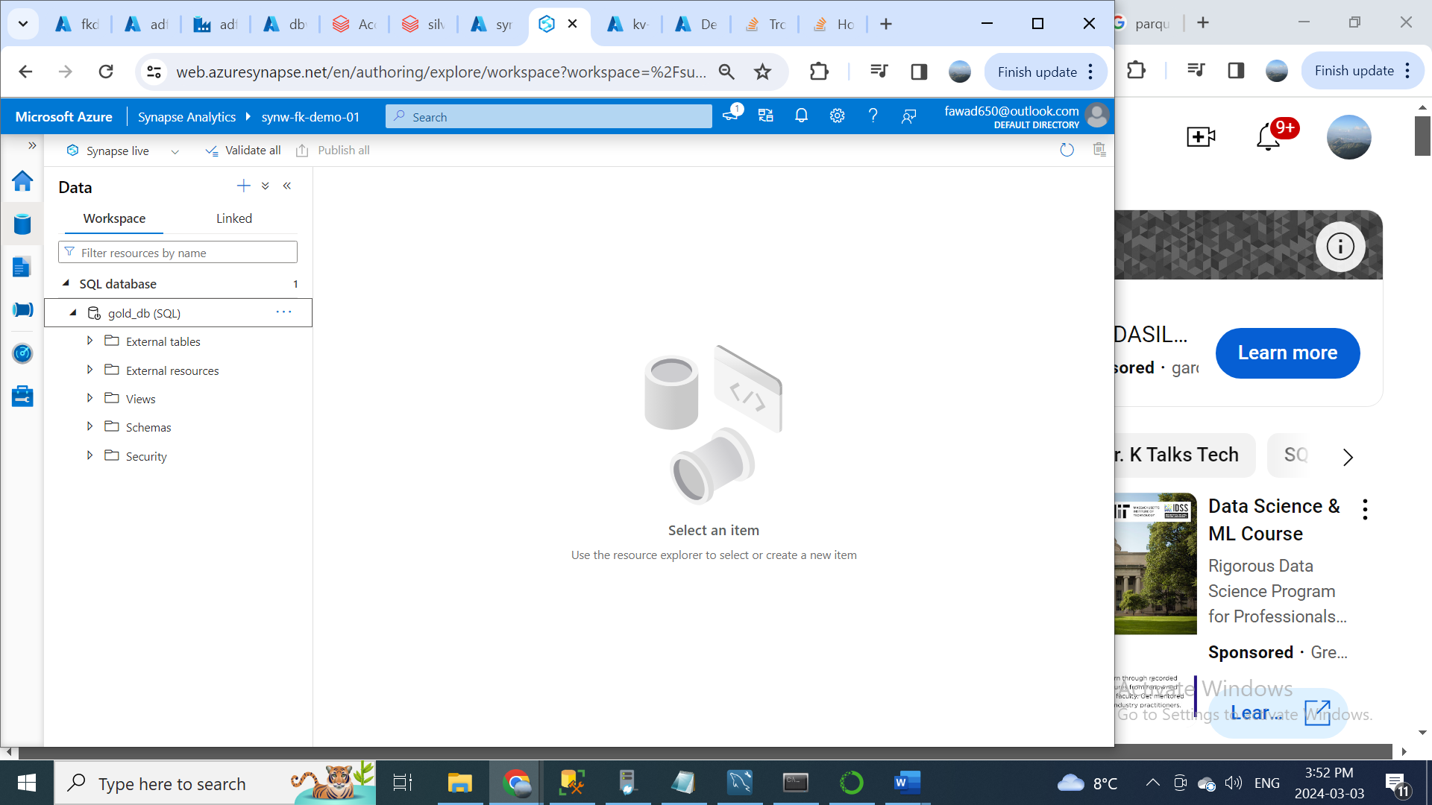

Now have all other options like External tables, External Resources, Views, Schemas and Security. So, we have already discussed that in Serverless SQL database, the data will be already existing in the data lake, we will be just using the build-in SQL pool to query the data directly from the data lake. The main reason for this is Azure Synapse Analytics already has a direct connection with the Azure data lake, so what I mean by that is for example as you can see here in the data tab. We are in the workspace tab. So, if we just switch from the workspace to the linked tab and under the linked tab you will be seeing something called Azure data lake. So, this Azure data lake Gen2 is already linked to Azure synapse analytics. When actually create the synapse workspace. If I expand the first one which is the primary data lake for this synapse analytics, as you can see here, we have these three containers bronze, silver and gold. Now we can click on this gold container and inside the gold container as you can find all the available transformed tables direct structure.

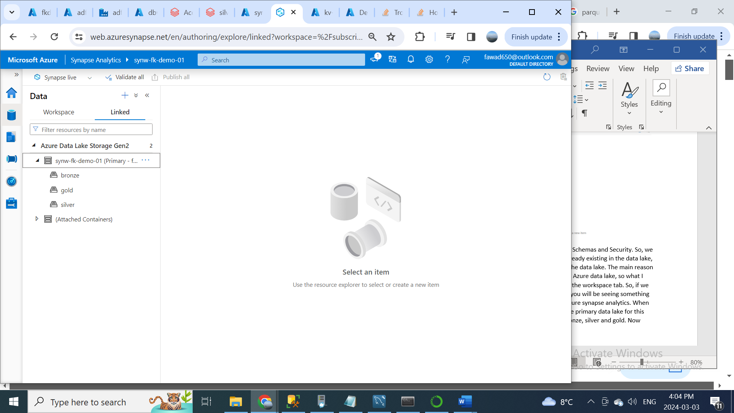

One of the most features of the synapse analytics is, you can just query the data in the data lake directly from the synapse workspace itself using the built-in SQL pool. For example, if you just want to query this address table you can just right click on this and you will be seeing something called new SQL script and if you select just click on this select top 100 rows and now it will ask you for the file type, as you can see here, there are three file formats available (parquet, text and delta). So, we know that the data in the gold container is in Delta format, I am clicking on this Delta format and click on apply. As you can see here it has automatically generated a script for us, which is the SQL command. This command is trying to fetch the data from the data lake directly, as you can see here this is path of the data lake location to the address table.

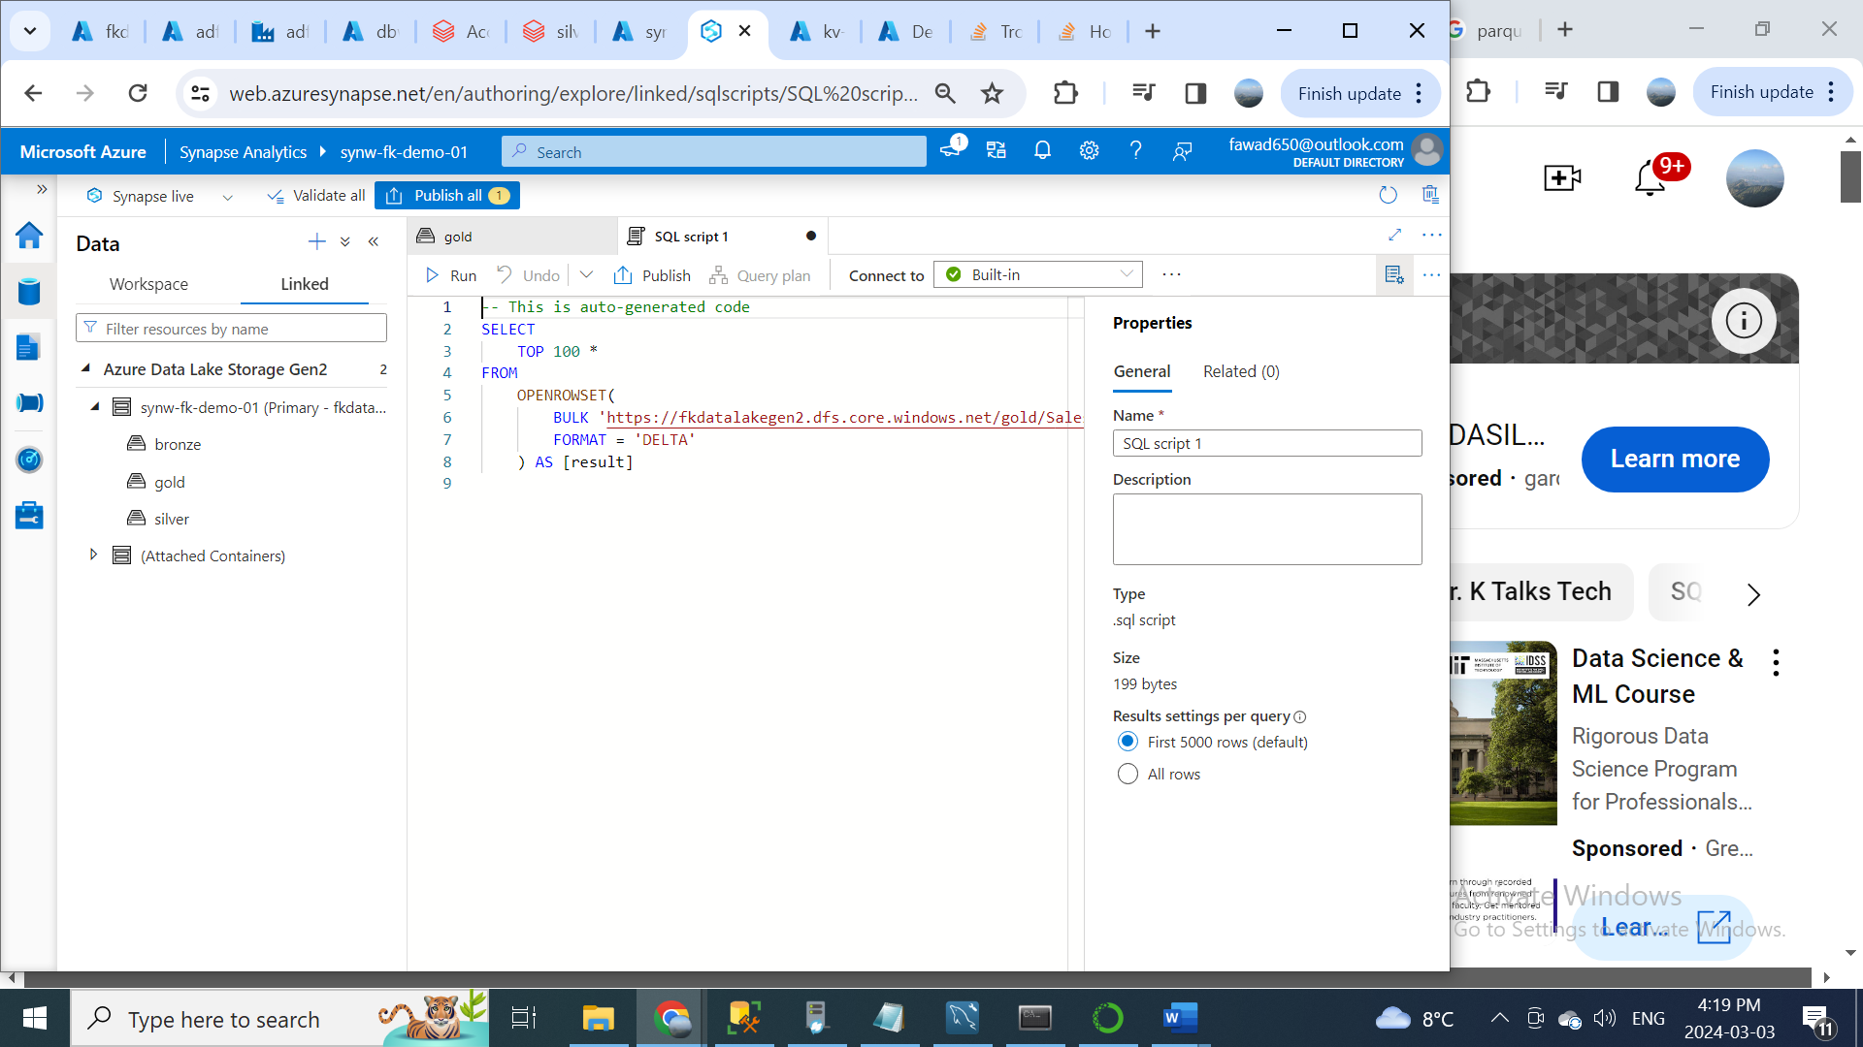

We can execute this command to query the address table, before that you can see an option called connect to and you can see here it has connected to the build-in serverless SQL pool. We are using this compute to query the data, which has been already stored in the data lake.

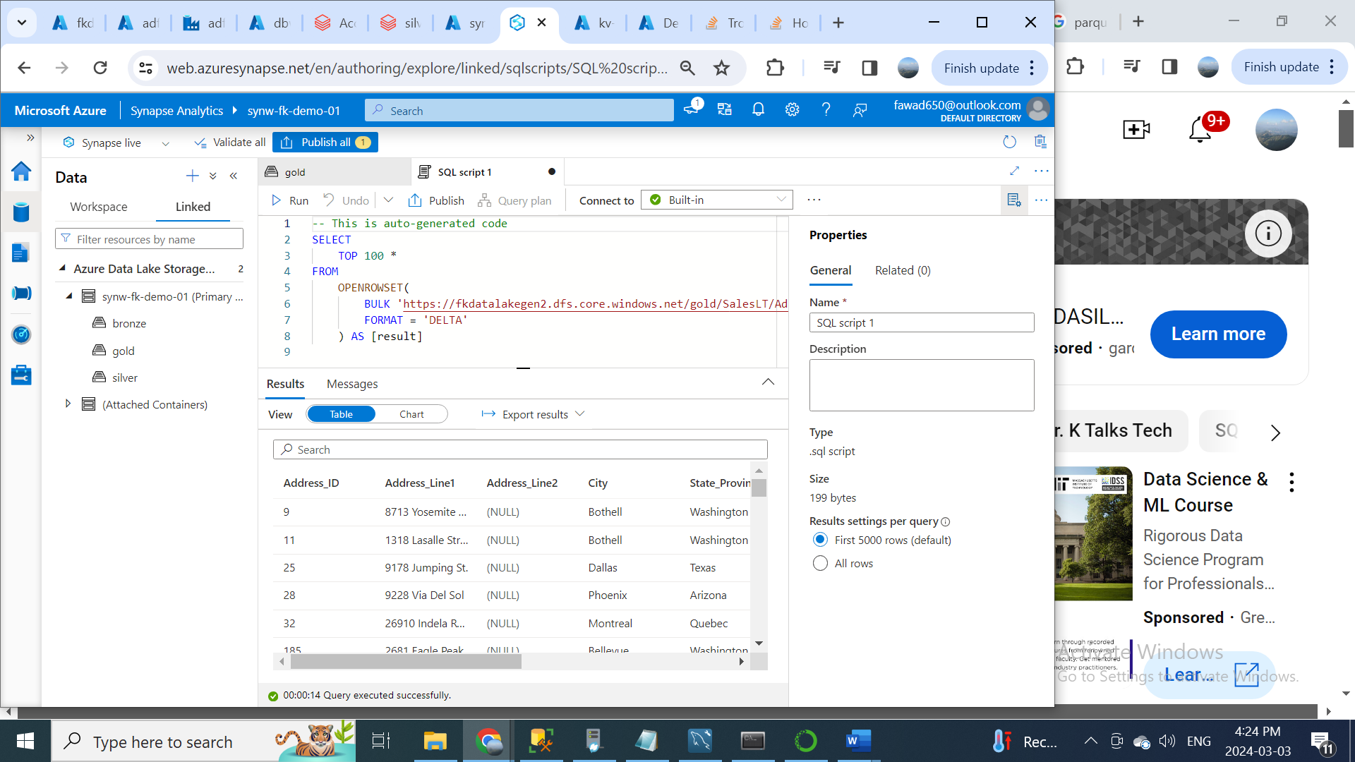

Important thing to note here is, we all know that the storage cost in the data lake is extremely cheap, since in serverless SQL database we just using the compute power and the storage is just the data lake, the total cost would be extremely cheap compared to the dedicated SQL database.

Now we have a script which queries the data directly from the data lake. Now hat we can do is, we can use the script to create a view in the serverless SQL database. I am going to modify this script to create view table. In the use database, we need to select gold_db instead of master.

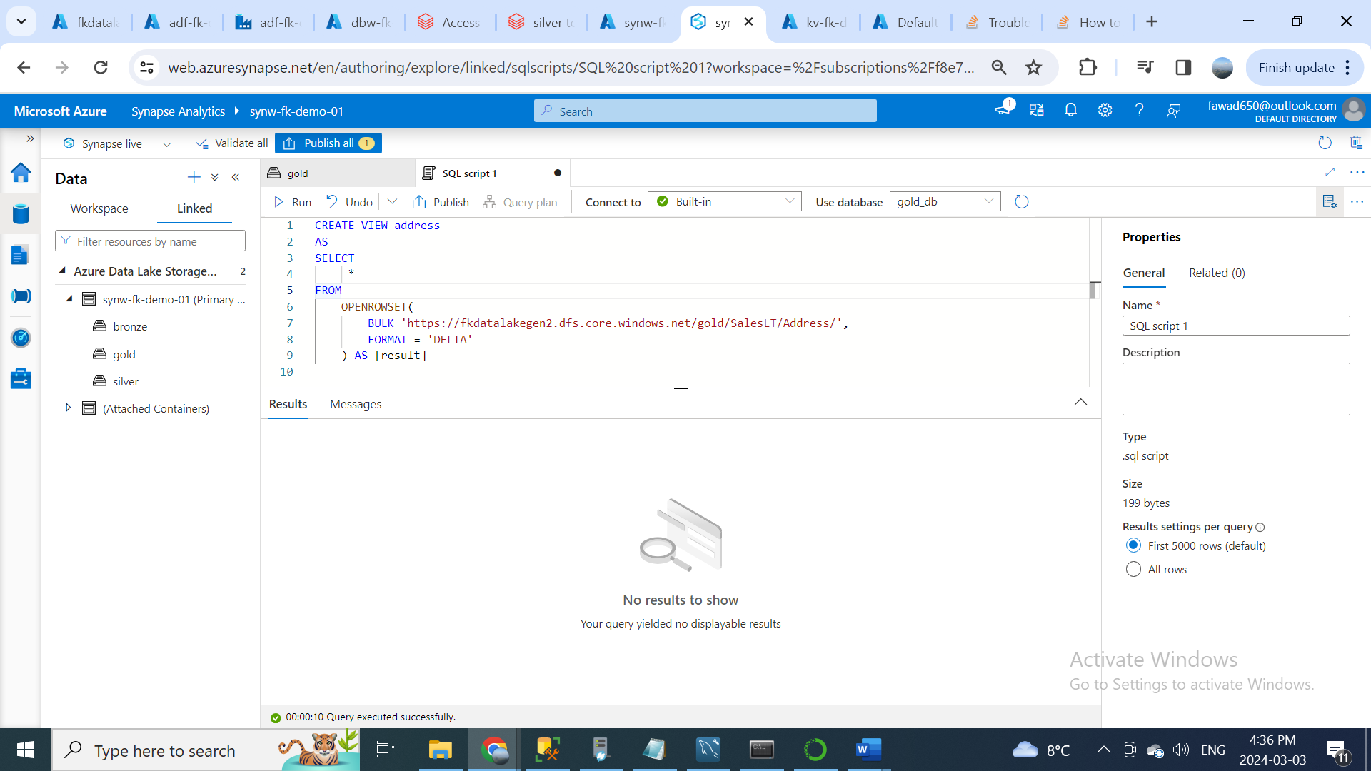

This view is referencing to the data lake location, if the data changes in the data lake, then this view will be automatically reflected. For example; if a new row is added to the address table in the data lake, then this view will be automatically reflected to get that additional record that has been added recently. Now we have created the view just for one table. We need to create the view for all the available tables inside the gold container. So, what we can do is, instead of just typing the create view statement for all the individual tables. We can create a pipeline, which dynamically create the views for all the tables.

Let’s see how we can create that pipeline, but this time we are going to create that pipeline using the Azure Synapse Analytics. To create this pipeline, we need to create a stored procedure with parameters that can dynamically create the views for all the tables in the gold container. You need to go to Develop tab and click new SQL query. Then we need to create the store procedure. This store procedure is just the select statement. This store procedure is going to get that value dynamically using the parameters. So, we will be using a pipeline to get all the tables names from the data lake and the table name will be passed to this stored procedure as a parameter and it will be used in the view name and also in the data lake location to create the views dynamically. We can just run this store procedure, then you will that the store procedure has been created successfully and now we can publish the changes.

So, now we have created the stored procedure under the gold_db serverless SQL database with name createSQLServerlessView_gold, and the next step would be creating the pipeline to use the stored procedure to create the views in the serverless SQL database. So, for that we need to create new linked service connection to connect to this serverless SQL database

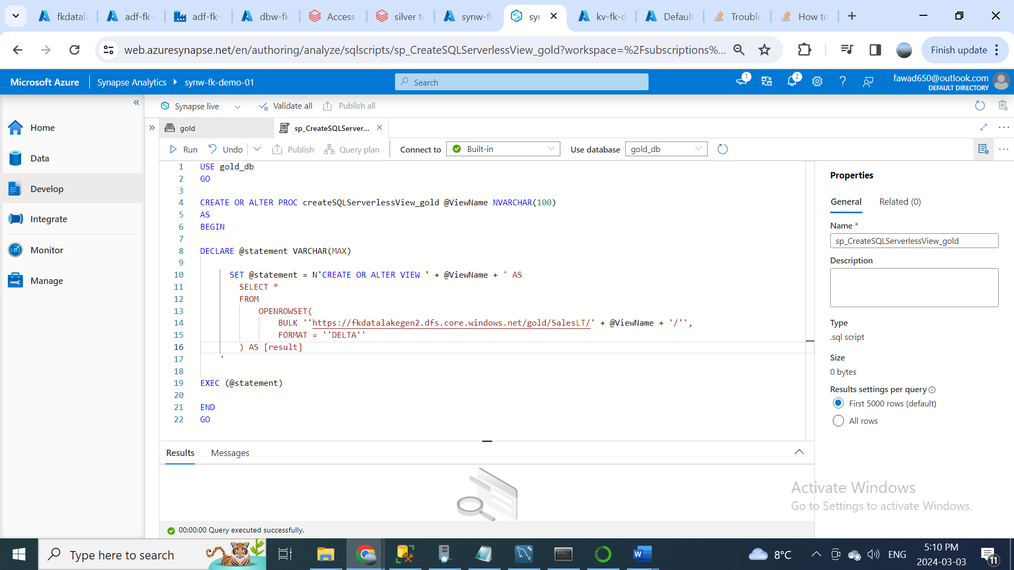

I am going to the manage tab and click on the linked services. Then click on the new button to create a new link service connection. Then search for Azure SQL database, select that and hit continue.

Enter database name, then leave select Auto Resolve integration run time. In Account selection method, I am going to go into manually and it is asking for fully qualified domain name, so we can get that information from Azure Synapse Analytics Workspace. Click on the properties tab in synapse analytics workspace. In the properties, you will see something called serverless SQL endpoint. This is the endpoint for our serverless SQL database. Copy that and paste in fully qualified domain name. Enter database name gold_db. Now it is asking for the authentication type. I am going to choose the authentication type a system assign managed identity. When we use the managed identity option, what it will happen is, it will use the username access to connect to this database. Then hit create and click on publish all to save the changes.

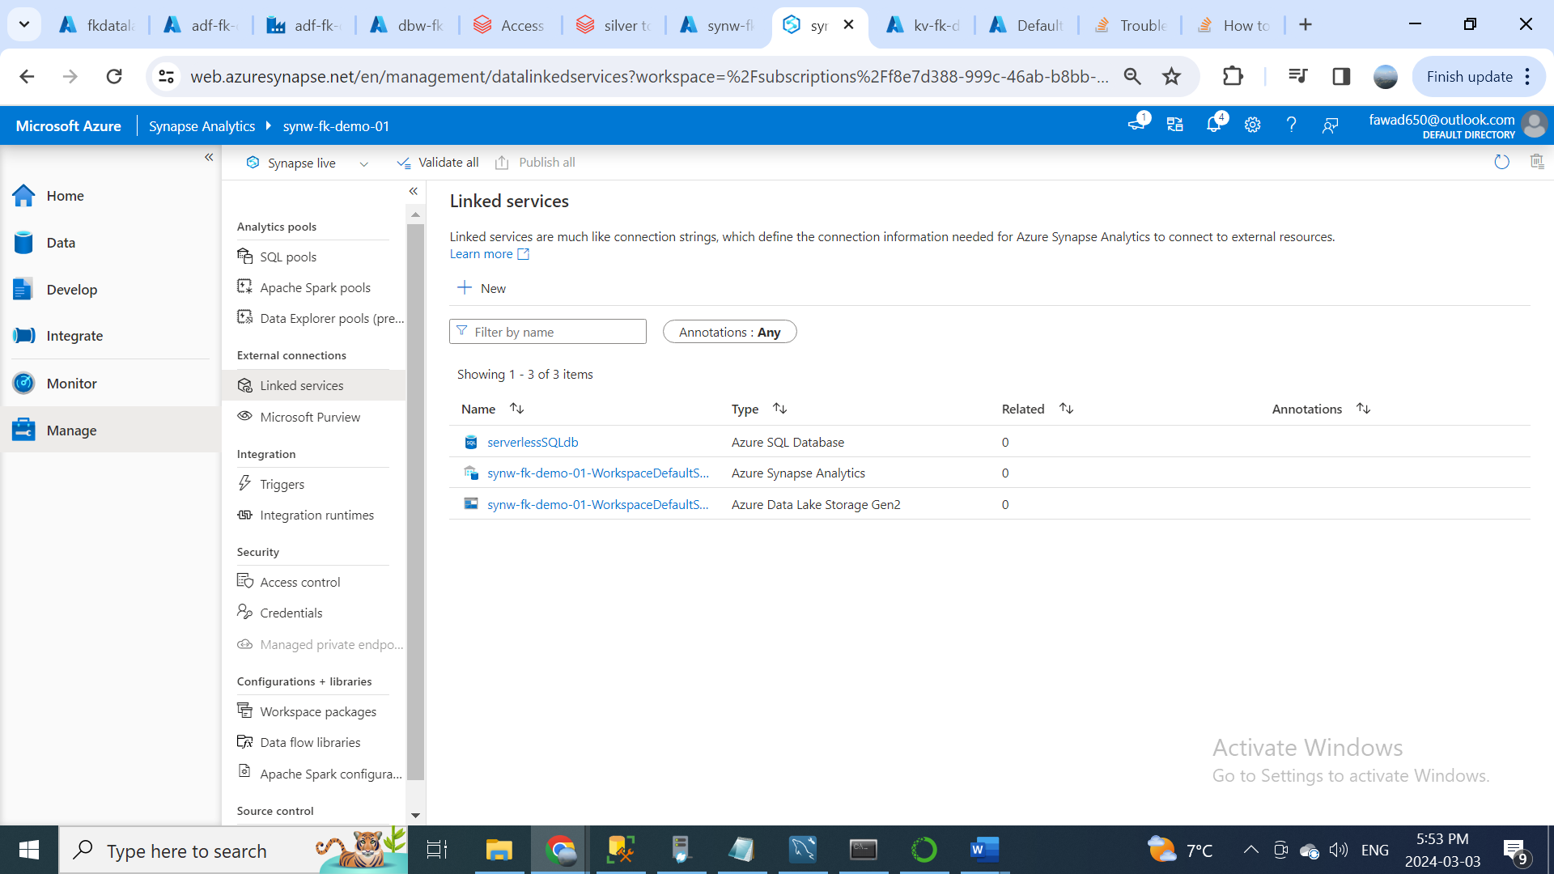

Now we have created the link service connection to connect the serverless SQL database. We can use this link service connection to access the stored procedure that we have created inside this database.

Let’s create the pipeline now. I am going to the integrate tab and inside the integrate tab, click on plus icon to create a new pipeline. In this pipeline I am going to search for get metadata activity. So, what this get metadata activity is going to do is, it is going to get all the table names from the data lake in gold container. First, give name to get metadata (Get Tablenames), after that click on settings tab, in settings tab we need to create a new data set for the data lake, I am going to select the data lake gen2, so it is just going to get the table name, I am going to select the binary file format here. Give the name (goldtables). Then we need to select the linked service connection. As we know that the synapse has direct connection to the data lake. We will choose the default link service connection to the data lake. Then choose the file path. Here I am choosing the goal location and SalesLT folder. Then hit ok.

So, we specify the gold container in the get metadata activity, so this will get all the table names from the container. For that we need to configure one additional step. In settings you will be seeing something called field list. Click on the new button and then click on the argument drop down, you will be seeing something called child items, so select that option. The reason to select this option is, this is going to get all the child ID items under the SalesLT folder.

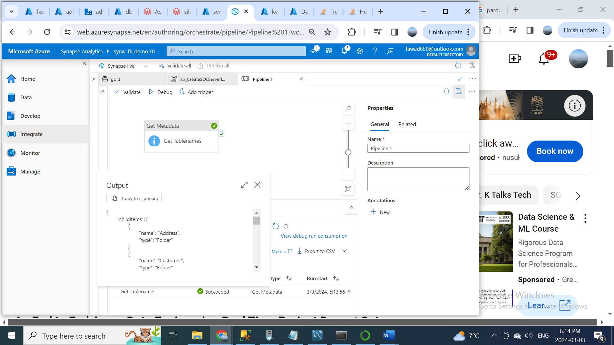

Get the table name from this name property and need to pass this name to the stored procedure to create the views dynamically. For that we need to create a new For Each activity to iterate through this list. Update the For Each name (For each table name), now we need to pass the child item array from the get metadata activity to this For Each. For that go to settings tab and in settings tab for items click on the option called add dynamic content. Then click on Get Tablenames and add childitems after output in the query and hit ok.

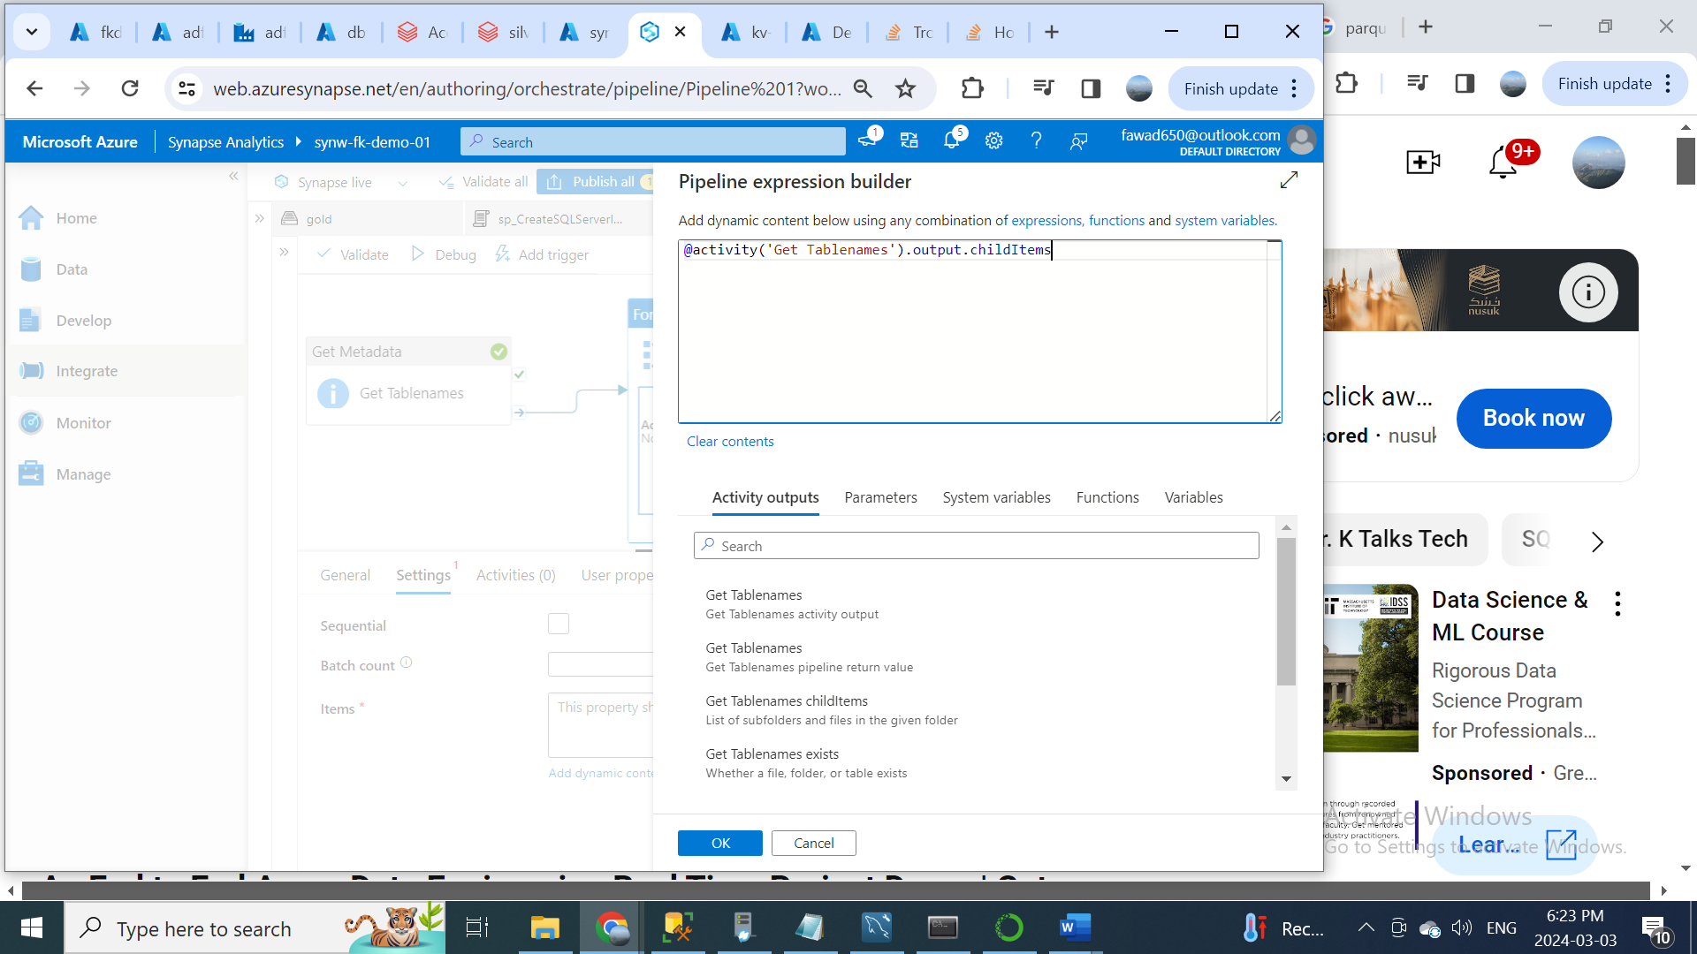

Now click on edit icon in For Each activity and search for Stored procedure. We have already created a store procedure in the serverless SQL database. We need to refer that store procedure in this activity. For that we need to go to settings tab, in the linked service connection just select the serverless SQL database one. In the stored procedure name select the createSQLServerlessView_gold. Then in stored procedure parameters click on new button to create a parameter. So, what is the name that we need to give here. For that go to the develop tab and open stored procedure SQL script. You can see that it is expecting us to give a parameter with a name ViewName. Copy that name and go to the pipeline and paste the name. Then select the data type (String) and then we need to specify the value. So, we are inside the For Each activity, we need to get the table name from the name property for every item. So, let’s specify that using the add dynamic content option. Click on the add dynamic content and click on for each table name and add (@item().name) and hit ok button. Now we have configured everything on stored procedure activity. Click on publish all to save the changes. This store procedure will get the table name from the outer loop as a parameter and it will create the views for all the tables names dynamically. After publish all, then click on add trigger to execute the pipeline.

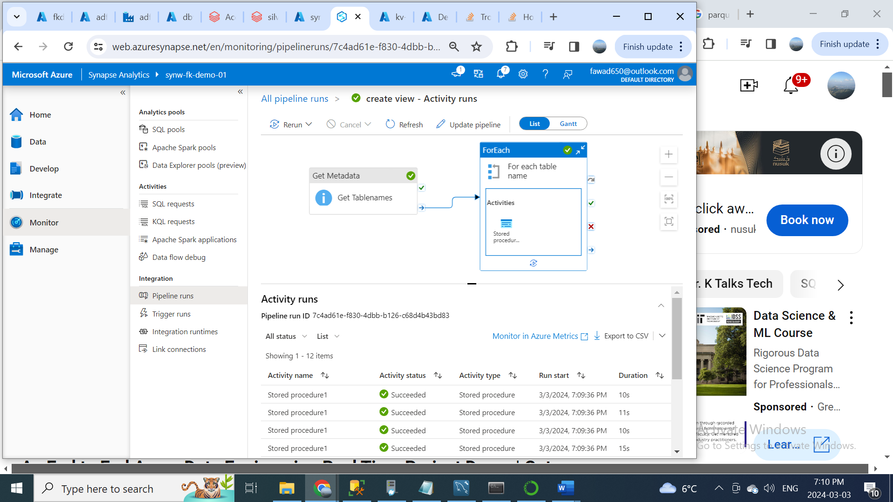

Then you can go to data tab and check gold_db views tab, you will see all the tables generated by pipeline.

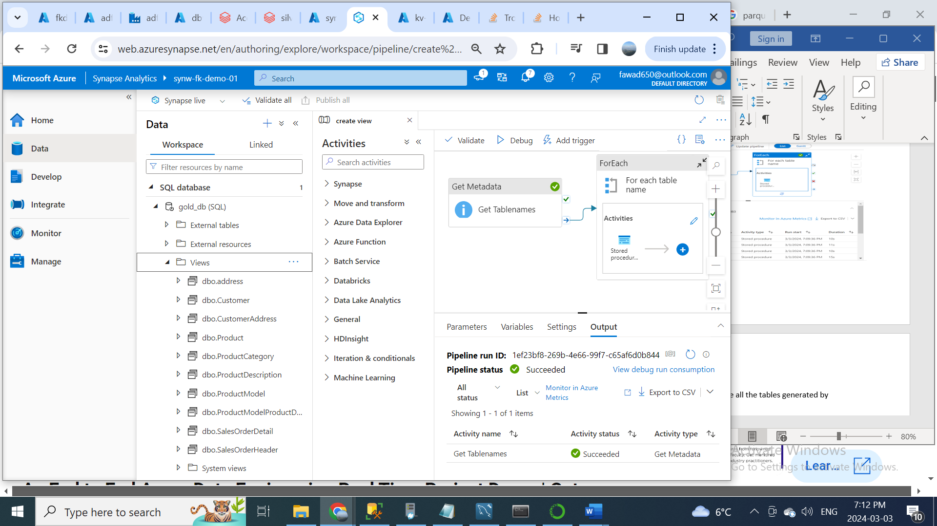

We don’t need to run this create view pipeline every time, whenever there is a change that is happening on the source unless and until if there is any change in the schema, we need to run this create view pipeline again. For example; if I am just querying this address table, so say for example if this schema changes for this address table in the source, then we need to run this create view pipeline to resonate those views. Other than that, the data is still existing in the data lake, so whenever there is a change that happens in the data source then the view will be automatically updated. Now we have completed the data loading part. We have created the views for all tables that exist in the gold container in the serverless SQL database.

In the next section, we can use Power BI to connect to this serverless SQL database and fetch all the views exists in this database to create the reports.

Power BI is business intelligence tool provided by Microsoft, using to Power BI you can create interactive dashboards and visuals, so as part of this data reporting section the first step would be using this Power BI desktop, we need to connect to the serverless SQL database to get all the data. So, for that under the Home tab there is an option called get data. Click on that and you will see there are a lot of different data sources connection supported in Power BI. So, for us we need to get the data from the Azure Synapse Analytics for that what we can do is, we can click on this more button. Inside that choose the Azure category, where you can find all the data sources related to Azure. Here we need to choose the Azure Synapse Analytics. Then click on connect button. Now it is asking for the database server details. First, we need to fill in the server endpoint. We can get serverless SQL endpoint from Azure Synapse Analytics properties tab. Enter database name (gold_db). After giving the database name now it’s asking for the data connectivity mode. There are two options over there, one is import and other one is Direct Query. So, the difference between these two modes, in import mode you will be loading the data completely from the serverless SQL database to Power BI and you can create reports on the loaded data. Whereas in the direct query mode the data will be still exist in the synapse database, you can use the Power BI to query the data directly from the Power BI itself. So, as part of this project, I am going with the import mode to load all the data from synapse to Power BI, then click OK. Now it will ask for the authentication method to connect to the database. I am going to use Microsoft account to connect to the database. Because my Microsoft account has access to the database in synapse, so I can use the same managed identity of my Microsoft account to connect to the database. Now click on the Microsoft account, let’s sign in using Microsoft account credentials. Then click on the connect button to connect to the database. Select all the views and click on Load.

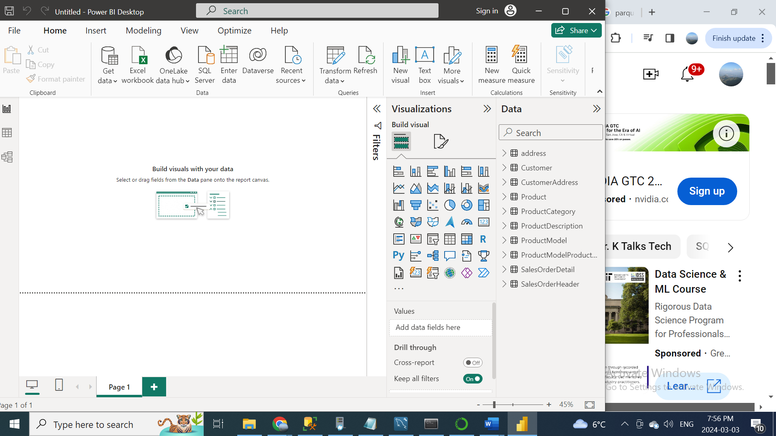

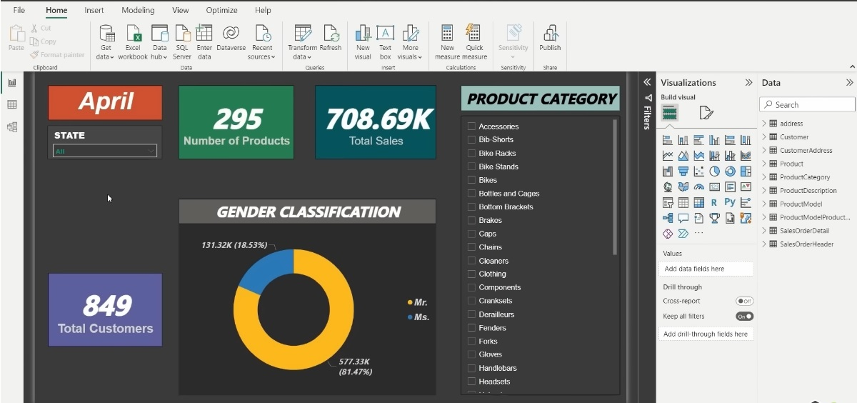

**Security and Governance:**

We have already used the Azure key vault in this project for storing the secrets and how we can use assured data factory to access the secrets, but we have not seen anything about the Azure Active directory (New name). we are going to explore the Azure active directory to create a security group and discuss some of the benefits of creating it. So, creating the security group and assigning appropriate permissions is one of the important components for doing any kinds of real-time data engineering project. This will be the last step for the project before doing the complete end-to-end testing.

You can’t add each and every one of them individually over here and this is very time consuming and it is very hard to maintain as well. To resolve this complexity, we can create a security group using Azure Active directory and you can add all the team members to that security group and after that we can give the resource group access to just the security group and once that is done all the members who belongs to the security group will have access to the resource group as well, this is really convenient. For example; in an organization if a new employee joins us a data engineer you can just add him to the security group and automatically the new user will get all the required access, where the security group is given access to.

Let’s create the security group, open Azure active directory, on the left side there will be an option called groups. This is the option we need to use to create a new security group in an active directory. Click on the new group button to create the security group. First, select the group type (security), then enter group name (Data engineer group). The important step is to assign owner to this group. Being the owner, this user can actually manage the group like adding new user to the group and removing user from the group and several other stuff. The Security group has been created successfully.

Now we need to go the resource group and go to Access control (IAM), then click on Add button and hit the Add role assignment. Then click on the contributor in Privileged administrator roles tab and hit Next. You will see there is an option called Assign access to, whether it is a User, group or service principal. Here we need to give the access to the security group. For that click on the select member option and as we can see the data engineer group that we have created recently. Choose the group and click on the select button on the bottom. Then we can click on this review and assign button to actually assign the contributor access to that security group. Now the security group have contributor access to this resource group. Which means that the other account which is the member of the group will also have contributor access to this resource group.

**Part 6: End to End Pipeline Testing:**

In this section, what we are going to do is, as discussed before in our data source which is on-premise SQL server database, if you try to add new row in any of the tables in the database and after adding the new row, if you run the Azure data factory pipelines, what will happen is, the Azure data factory will connect to the on-premise SQL server database and it will copy all data including the new row and put the data into the bronze layer inside the data lake and once this is done the Azure databricks will fetch all the data from the bronze layer do the two level of transformation and put the transformed data into the silver layer and finally into the gold layer and after that the final transform data in the gold layer will be loaded to the database in Azure synapse analytics, so once that is done the Power BI will be integrated with the Azure synapse analytics get the latest data from the database and finally the visuals that we have created using Power BI will be reflected with the new row that has been added into the source. Since, all these components are integrated with each other all these things will be performed automatically once we have run the Azure Data Factory pipeline. So that’s what we are going to test in this End-to-End pipeline testing section.

We need to run the Azure data factory pipeline in an automatic way. We can achieve this by configuring a trigger in the pipeline and the trigger can be a schedule trigger, which runs this pipeline on a schedule bases or it can be given event-based trigger, which runs this pipeline automatically when a specific event occurs. I am going to create a new schedule trigger for this pipeline as part of this project. For that click on Add trigger option, you will see something called New/Edit to create a new trigger. Click on that button. Then click on this choose trigger drop down, here we don’t have any triggers yet, so we need to create a new one, click on new option to create a new one trigger.

First, enter the name (schedule_trigger). In type select Schedule. Then select Time Zone based on your region. The most important one is Recurrence. This is mainly used to specify the frequency for this pipeline to run. The default one is 15 minutes, which means that this pipeline will run every 15 minutes. The better approach is to run the environment on daily load. Select the time when you want to trigger the pipeline, after that click ok and click publish the changes.